Read the 2 statements. They are first person accounts of UFO encounters.

When you have read them complete the notes on a statement sheet.

After you have completed the sheet think about these questions:

Do their recounts fit together?

Are there any contradictions?

What would you want to ask them if you could talk to them now?

Cabansag Statement

On 26 Dec 80, SSgt Penningston and I were on Security #6 at Woodbridge Base. I was the member. We were patrolling Delta NAPA when we received a call over the radio. It stated that Police #4 had seen some strange lights out past the East Gate and we were to respond. SSgt Penningston and I left Delta NAPA, heading for the East Gate code two. When we got there SSgt Steffens and A1C Burroughs were on patrol. They told us they had seen some funny lights out in the woods. We notified CSC and we asked permission to investigate further.

They gave us the go-ahead. We left our weapons with SSgt Steffens who remained at the gate. Thus the three of us went out to investigate. We stopped the Security Police vehicle about ]00 meters from the gate. Due to the terrain we had to on by foot. We kept in constant contact with CSC. While we walked, each one of us would see the lights. Blue, red, white, and yellow. The beckon light turned out to be the yellow light. We would see them periodically, but not in a specific pattern. As we approached, the lights would seem to be at the edge of the forest. We were about 100 meters from the edge of the forest when I saw a quick movement, it looked visible for a moment. It looked like it spun left a quarter of a turn, then it was gone. I’m advised SSgt Penningston and A1C Borroughs(?). We advised CSC and proceeded In extreme caution. When we got about 75-50 meters, MSgt Chandler/Flight Chief, was on the scene. CSC was not reading our transmissions very well, so we used MSgt Chandler as a go-between. He remained back at out vehicle. As we entered the forest, the blue and red lights were not visible anymore. Only the beacon light, was still blinking.

We figured the lights were coming from past the forest, since nothing was visible when we past through the woody forest. We would see a glowing near the beacon light, but as we got closer we found It to be a lit-up farm house. After we had passed through the forest, we thought it had to be an aircraft accident. So did CSC as well. But we ran and walked a good 2 miles past out the vehicle, until we got to a vantage point where we could determine that what we were chasing was X only a beacon light off In the distance. Our route through the forest and field was a direct one, straight towards the light. We informed CSC that the light beacon was farther than we thought, so CSC terminated our Investigation. A1C Burroughs and I took a road, while SSgt Penningston walked straight back from where we came. A1C Burroughs saw the light again, this time it was coming from the left of us, as we were walking back to our patrol vehicle. We got in contact with SSgt Penningston and we took a walk threw where we saw the lights. Nothing. Finally, we made it back to our vehicle, after making contact with the PC’s and informing them of what we saw. After that we met MSgt Chandler and we went in service again after termination of the sighting.”

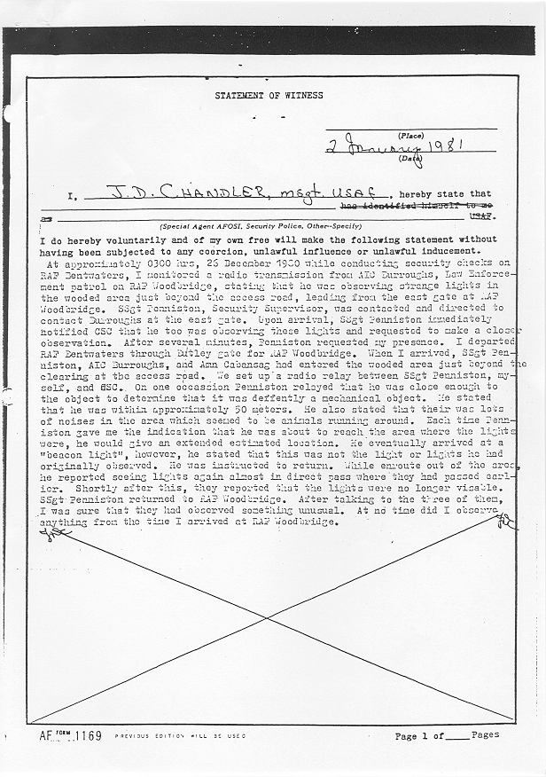

Notes on Statements

 | Cabasang | Chandler
Where did they go?
What did they see?
What did they do?
Other information:

