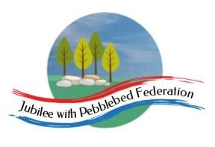
Learning
from Home

Year:  Wk beg: | Lesson One | Lesson Two | Lesson Three | Lesson Four
Monday | Reading  Read library book or allocated bug club books | English  https://classroom.thenational.academy/lessons/to-engage-with-a-text-64vk4c | Maths  https://classroom.thenational.academy/lessons/measuring-lengths-to-the-nearest-cm-or-mm-65k64d | Geography  https://classroom.thenational.academy/lessons/what-are-the-countries-of-europe-69k6cr
Tuesday | Spelling  Learn your spellings | English  https://classroom.thenational.academy/lessons/to-answer-retrieval-questions-60u30r | Maths  https://classroom.thenational.academy/lessons/measuring-length-and-drawing-lines-of-a-given-length-in-mixed-units-69j3ed | RE  https://www.bbc.co.uk/bitesize/topics/ztkxpv4/articles/zdjjf4j
Wednesday | Spelling  Learn your spellings | English  https://classroom.thenational.academy/lessons/to-answer-inference-questions-c5hpct | Maths  https://classroom.thenational.academy/lessons/making-appropriate-estimates-of-length-by-comparing-69hk8c | PE  https://www.youtube.com/watch?v=0B1uJGWKxCg
Thursday | Reading  Read library book or allocated bug club books | English  https://classroom.thenational.academy/lessons/to-analyse-language-69hk0c | Maths  https://classroom.thenational.academy/lessons/length-and-measurement-application-ccr68e | PSHE  https://classroom.thenational.academy/lessons/fireproof-64t3er
Friday | Reading  Read library book or allocated bug club books | English  https://classroom.thenational.academy/lessons/to-analyse-a-characters-emotions-61j6ad | Maths  https://classroom.thenational.academy/lessons/to-calculate-perimeters-of-2d-shapes-in-cm-and-mm-cnj3ae | Music  https://www.youtube.com/watch?v=nEH7_2c644Q

