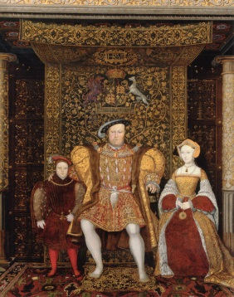
Quiz on The Tudors – See what you can remember first and then find out afterwards.
- When did the Tudor era start?
- Who was the first Tudor monarch?
- Whom did this monarch defeat in battle?
- What were the two houses called that fought in this battle and what were the colours of the roses that represented the houses?
- What was Henry’s (VIII) brother called?
- Name all six of Henry’s wives.
- Now put them in order of marriage?
- What happened to each one?
- Name three of Henry VIII’s palaces/castles.
- What were Henry’s children called?
- Who of the three reigned first?
- Who of the three reigned the longest?
- Name a writer who lived during the Tudor era.
- Name an explorer who lived during the Tudor era.
- When did the Tudor era end?
- What was the name of the next monarch of England and what was the family name?

Answers
- 1485
- Henry VII
- Richard III
- York and Lancaster. York – white rose. Lancaster – red rose
- Arthur
- Catherine of Aragon, Anne Boleyn, Jane Seymour, Anne of Cleves, Catherine Howard, Catherine Parr. (Variations of spellings do occur)
- See answer to f
- Divorced, beheaded, died, divorced, beheaded survived
- Leeds Castle, Windsor Castle, Westminster Abbey, Tower of London, Hampton Court (amongst many others)
- Elizabeth, Mary, Edward (there were others out of wedlock)
- Edward as Edward VI
- Elizabeth - 1558 – 1603 (45 years)
- William Shakespeare
- Francis Drake, Walter Raleigh (British)
- 1603
- James I of the House of Stuart

