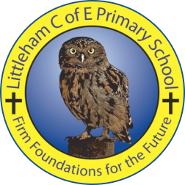
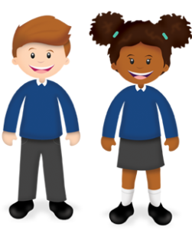
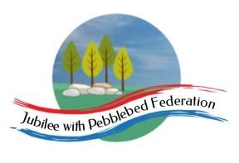

Year: 6  Wk beg: 30/11/20 | Lesson One | Lesson Two | Lesson Three | Lesson Four |  |  | Lesson Five
Monday | Reading – Own book.  Spellings – sheet taken home  https://classroom.thenational.academy/lessons/to-identify-the-features-of-an-explanation-text-6tgk2r  To know features of an explanation text. | Maths  I can multiply a decimal by a whole number.  https://classroom.thenational.academy/lessons/multiply-a-decimal-number-by-a-whole-number-6mwpcd  PRACTISE TABLES |  | Science – Light  To know what light is.  https://classroom.thenational.academy/lessons/what-is-light-c4w30d  To know what a reflection is.  https://classroom.thenational.academy/lessons/what-is-reflection-and-how-can-we-use-it-6mt3gd
Tuesday | Reading – Own book.  Spellings – sheet taken home  Recap on causal connectives – Primary Resources website.  Research How we see and write an explanation text for it. Use what we have covered in class so far. Must have time adverbials to introduce new paragraphs and MUST have causal connectives. | Maths  I can multiply numbers using known and derived facts.  https://classroom.thenational.academy/lessons/solve-multiplication-problems-using-known-and-derived-facts-6ngk2t  PRACTISE TABLES |  | RE  Why do some people believe in God and others don’t?  Try to think of some reasons for this.  Look up the following words: theist, atheist and agnostic. | MFL  I am learning Spanish numbers  https://www.youtube.com/watch?v=8fPF1eGvLLM  I know Spanish greetings  https://www.primaryresources.co.uk/mfl/mfl_spanish.htm
Wednesday | Reading – Own book.  https://classroom.thenational.academy/lessons/to-understand-and-sequence-how-bees-make-honey-cgwk2c?activity=video&step=1  To know how bees make honey. | Maths LO  Identify, describe and represent fractions  https://classroom.thenational.academy/lessons/to-identify-describe-and-represent-fractions-ccw3ee  PRACTISE TABLES |  | Computing  If you can access Scratch, create a game similar to one you did earlier last year.  Try putting a bug in it!
Thursday | Reading – Own book.  Spellings – sheet taken home  LO – To orally explain a process  https://classroom.thenational.academy/lessons/to-orally-explain-a-process-6mt3gd | Maths LO  To understand equivalence in fractions  https://classroom.thenational.academy/lessons/understanding-equivalence-75hkge PRACTISE TABLES AND DIVISION RELATED TO THEM |  | PSHE  https://classroom.thenational.academy/lessons/community-care-cctp8c |  | PE  Fitness – push-ups, squats, leg drives, star jumps, shuttle runs.
Friday | Reading – Own book.  Spellings – sheet taken home  Write an explanation for How Bees Make Honey. This is a linear sequence so it will need time adverbials. Remember to use causal connectives. (because, causing, this results in, resulting in, consequently) | Maths  Transum Fractions  PRACTISE TABLES |  | Light cont  BBC Bitesize Light and Dark  https://www.bbc.co.uk/bitesize/topics/zbssgk7  Research how shadows form, how light is reflected and how light can be split up into its component colours.

