Hub Weekly Challenges 20
Week beginning 1st March 2021
Kensuke’s Kingdom Week 2  1.This week sit back and enjoy Chapters 3 and 4.  2. Can you draw Michael’s journey as you listen or read Chapters 3 and 4?  3.Have a go at playing ‘The Survival Game’. Imagine, like Michael, you are adrift at sea. You only have a few items with you as not everything survived. Can you rank the items remaining in the order of importance? (see attached sheet)  You could cut all the items out from p.2 to help you with this. | The Debate Section!  Should children be allowed to wear their own clothes to school?  What do you think? This week can you have a debate in your home about this?  Watch the lego debate for an idea of how to hold one!  https://www.youtube.com/watch?v=EDTk-_Lt6sQ  Can you ask some members of your household to agree with the above debate (proposition speakers) and some to disagree with it (opposition speakers)?  It can be hard to debate something when you are arguing against what you believe!  Can you write or type a list of all the reasons FOR wearing your own clothes and the reasons AGAINST wearing them?
The Tasty Challenge  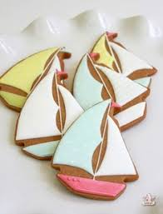  Have a go at making some boat shaped biscuits. Do you think they will look like the Peggy Sue?  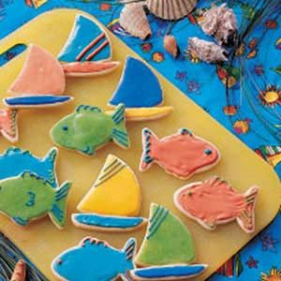  The recipe is in your paper pack or on Google Classrooms. The first thing you will need to do is to make yourself a cardboard boat template. You will need this to cut around your cookies. Enjoy making them. Decorating them will be fun! Make the sails nice and bright. You will need to make some icing by using icing sugar, water and some food colouring. Don’t make it too runny! | Maths Madness  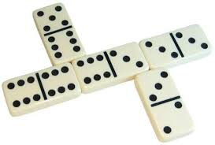  - Can you solve the Domino Window investigation?  2.Play the ‘Blind Hughie’  Domino Game.  1.Revisit Pyramid Solitaire. If you can’t remember how to play, revisit the game with the link below:  https://www.youtube.com/watch?v=dnRlETGqHec  2.Try this new game called ‘Garbage’. I think you will like this one. You need just two players.  https://www.youtube.com/watch?v=an75_10ZNZI  You will find paper copies in your learning pack if you can’t log onto Google Classrooms.
Arty Crafty  Have a go at making an origami boat like ‘Peggy Sue’.  You can watch how to make one here:  https://www.youtube.com/watch?v=BM6G_QLxkCE  Or use the paper instructions in your pack.  You can add extra details too….sails or bunting! | Stay healthy!  Can you spot or find the following on your daily walk? You can use a tally, if you find more than one!  Postbox  Green cars  Bikes  Bird Feeders  Bus  Gnomes  Cats  Someone gardening  Recycling bins  Bird on a wire  Interesting stone/shell  Or you could log onto PE with Joe on a Mon, Wed and Fri morning at 9.00 on youtube or you can play them back at any time.  Take the quiz to find out why it is important to stay hydrated. Infuse your water with flavour by adding fruits like berries, cucumber, lemon or lime. You could also freeze ice cube trays with berries and add this to your water to keep it extra cold.  https://www.n4hk.com.au/game/jimmysthirsty/  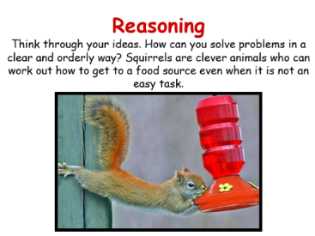  You are doing so well learning from home now. Keep on going! This week be inspired to become like a squirrel who thinks problems through carefully and doesn’t give up. Sometimes, it takes several attempts to get something right.  Looking after your Mental Health  Remember to log on to Google Classrooms and watch Mrs Fagan’s Mental Health sessions each week. A paper copy, is attached if you can’t manage to log on.
Icebreakers…
Discuss with your family, maybe over a mealtime or when you have a few minutes to spare….

If I gave you £100, what would you spend it on? £1,000? £10,000?
Collective Worship

Our value this half term is Justice.

Every week you will find a weekly collective worship by Rev Benedict, Rev Steve, Brooke (Youthworker) or Sam Burnett (Baptist Minister of The Wave) on Google Classrooms.
Mrs Padbury leads a Collective Worship every Monday.
There’s also a sheet full of ideas on Google Classrooms for you to do together with your family. This will be in your pack if you are getting a paper copy.
The Game Exchange!  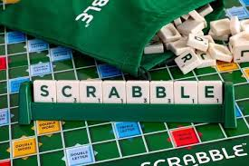  In your home learning box this week, I’ve sent you home with some games to play.  Have fun!  Remember you can exchange them for new ones whenever you are ready! | Your turn!  Would you like to set any of the challenges next week? Send me any of your ideas. Maybe you would like to set a Tasty Challenge or the next Would You Rather. Be creative!

Parents, please be aware that when accessing the YouTube clips I post, that adverts could pop up. It is always advisable to have your home security filters on. Please let me know if there are any issues.
This will be on the school website and on Google Classrooms by 8.30am every Monday. Please send me your responses and pictures by Friday 4.00pm please if you want your entries to be included in our Hub Exhibition. Send me an email to hubteacher@littleham.devon.sch.uk or reply in Google Classrooms.

