Year 2 Learning from Home Grid
Week Beginning 22.02.21

Think about how we can develop your child’s learning behaviours. This week we are looking at listening to others and thinking how they might feel.  Tell Mrs Hooper how your child has shown this behaviour this week either by email or returning the slip. | 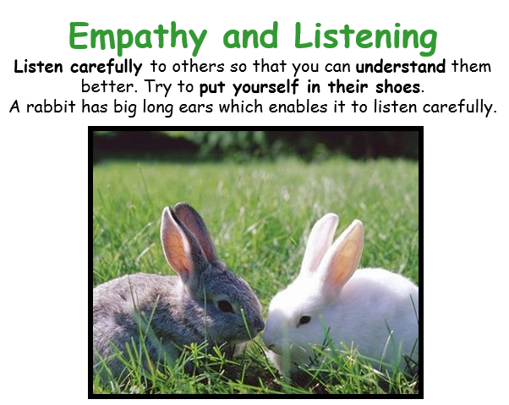
Monday
Today is Mental Health Day , please read the poster and choose as many of the activities as you would like to do. If you would like to keep up reading , phonics and writing the activities are below, if not you can push these activities on into tomorrow.

Reading (30 Mins)
Read the book you have been sent in your home learning pack, these are the sounds you are working on. There is also a book specific to you on Bug Club as well as phonic games you can play.

Phonics (30 Mins)
Sound ir as in bird, log into the bug club lesson in your Bug Club account. Alternatively you could watch the video link on you tube :
https://youtu.be/sgXywhMY_CI

Now complete worksheet 1 from the pack you have been given or online in bug club, If you can’t type on the sheet online you can write the answers in a list and send it to me by email at Y2Teacher@littleham.devon.sch.uk

English (30 Mins)

For Health and Wellbeing day you could enjoy this video of I love Bugs being read using this link: https://youtu.be/xEJ10k1_Fjg
We will be looking at learning about bugs and using this book more in English but for today just enjoy.
Please note that your child will need supervising whilst using you tube which can sometimes present inappropriate adverts.

Maths (30 Mins)
This week you can support your child to count on and back in fives like the clock face does in minutes. It is as important to count on as it to count back.
Please see your pack or google classroom for todays maths. If you are on Google you may need to write your work on a sheet and email this in. You have been sent or set the work appropriate for you. We are all learning to tell the time.

Tuesday
Reading (30 Mins)
Read the book you have been sent in your home learning pack, these are the sounds you are working on. There is also a book specific to you on Bug Club as well as phonic games you can play.

Phonics (30 Mins)
Sound er as in herb , log into the bug club lesson in your Bug Club account. Alternatively you could watch the video link on you tube :
https://youtu.be/k3bCEfX42jg

Then you should be able to complete worksheet 2 in your pack.

English (30 Mins)
Look at the picture and talk about it with your grown up.
Remember a noun is an object name or place. You can watch the bbc bitesize clip on this link if you need a reminder: https://www.bbc.co.uk/bitesize/topics/zrqqtfr/articles/zpd8ng8
Assessment task , please don’t help your child with this list, this is to help us know where they need support with learning, it is ok if they make spelling mistakes and cant remember what an expanded noun phrase is.
You need to write a list of expanded noun phrases you can see in the picture on the sheet provided on paper or in Google ?

Maths (30 Mins)
This week you can support your child to count on and back in fives like the clock face does in minutes. It is as important to count on as it to count back.
Please see your pack or google classroom for todays maths. If you are on Google you may need to write your work on a sheet and email this in. You have been sent or set the work appropriate for you. We are all learning to tell the time.

Science (60 Mins)
Minibeast Hunt
If you have a garden or outdoor space it is time to go looking for minibeasts ! If you don’t have a garden you could go to an outdoor space for your daily exercise.
Talk about what you think you might find when you go hunting.
Take a sneaky peek into holes and under rocks, lift stones and logs and see what you can find.
You could take photos to show what you found and email them in or draw pictures and email them. Watch closely how they move and the other creatures they were found with. Have fun !

Wednesday
Reading (30 Mins)
Read the book you have been sent in your home learning pack, these are the sounds you are working on. There is also a book specific to you on Bug Club as well as phonic games you can play.

Phonics (30 Mins)
Sound ear as in learn, log into the bug club lesson in your bug club account. Then you should be able to complete activity sheet 3.

English (30 Mins)
I have collected some of the expanded noun phrases from the poem.
Can you match the adjectives to the right boxes using the height and shapes of the words.
E.g
I | love
love | I
bugs | bugs

Maths (30 Mins)
This week you can support your child to count on and back in fives like the clock face does in minutes. It is as important to count on as it to count back.
Please see your pack or google classroom for todays maths. If you are on Google you may need to write your work on a sheet and email this in. You have been sent or set the work appropriate for you. We are all learning to tell the time.

DTEC (45 Mins)
Using your photo or drawings from your walk can you use what you have at home to make a junk model of one of the bugs you found. Please take a photo and email it to me. You could also draw a labelled picture to show whatyou used to make your model and label it.

Collective Worship (15 Mins)
Please log into you Google classrooms account to view the Collective Worship from Mrs Padbury.
Thursday
Reading (30 Mins)
Read the book you have been sent in your home learning pack, these are the sounds you are working on. There is also a book specific to you on Bug Club as well as phonic games you can play.

Phonics (30 Mins)
Practice the sounds you have been learning this week by completing sheet 4 in your pack. You could also play the practice games on your Bug Club account.

English (30 Mins)
Today we will look at another Emma Dodd description poem and then think about it. Please watch this link on you tube. Please be careful of ads that may pop up with your filters as this is a you tube link : https://youtu.be/6A0j_9r2D3Y

Now look at the poem and think about the questions on the sheet. You can photograph your ideas and email to me or turn in on the Google classrooms.

Maths (30 Mins)
This week you can support your child to count on and back in fives like the clock face does in minutes. It is as important to count on as it to count back.
Please see your pack or google classroom for todays maths. If you are on Google you may need to write your work on a sheet and email this in. You have been sent or set the work appropriate for you. We are all learning to tell the time.

Geography (30 Mins)
Draw a map of the area that you went to do your mini beast hunt. You could include what was on the ground eg grass or rocks. You could also include any trees, bushes , piles of logs. Label your map and email it to me please.

Friday
Reading (30 Mins)
Read the book you have been sent in your home learning pack, these are the sounds you are working on. There is also a book specific to you on Bug Club as well as phonic games you can play.

Phonics (30 Mins)
Enjoy the assessment game assigned to you in Bug Club using the log on code you have been given. You earn points for each game to spend in the Bug Club shop.

English (30 Mins)
Look at both of the poems again. Do you have a favourite ? I would like you think about which one and why.
Either on your paper sheet or on Google classroom please tell me which is your favourite poem and why ? What do you like about it ? Which is your favourite line from the poem ? Which is your favourite bug or dog ? You can draw and colour your favourite as neatly as you can. If you are on google you might be able to use the drawing tools.

Maths (30 Mins)
This week you can support your child to count on and back in fives like the clock face does in minutes. It is as important to count on as it to count back.
Please see your pack or google classroom for todays maths. If you are on Google you may need to write your work on a sheet and email this in. You have been sent or set the work appropriate for you. We are all learning to tell the time.

Mental Health and Well Being
Please view the link from Mrs Fagan about sharing worries if you are able.
If you can, and you have a phone/tablet or PC, watch this session’s Powerpoint or Loom video on our school website.
http://www.littleham.devon.sch.uk/website/mental_health/535426
If you can’t, don’t worry, just have a go at this activity.

