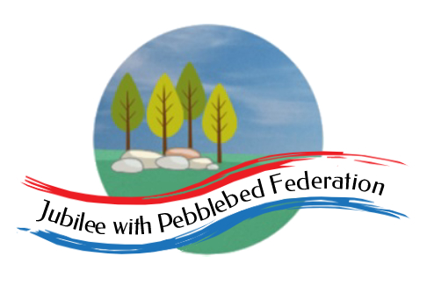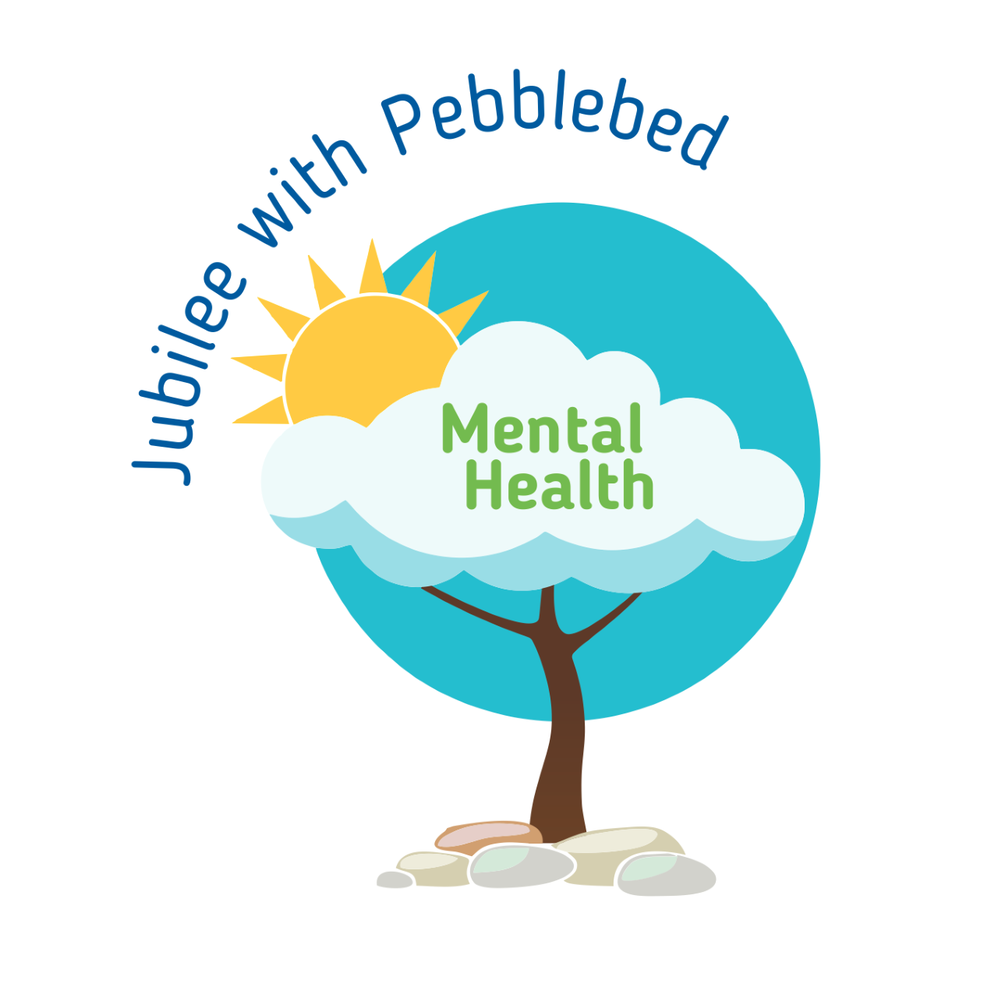

’10 a day’ for Positive Mental Health 3
While we are working from home it is important that you continue to support your mental health. One way of doing this is to continue to use the ’10 a day’.
Below are some activities to try at home this week. Each one is linked to one of our ’10 a day’.
10 a day | Activity
The following link gives information about how to deal with emotions directly linked with the Coronavirus from Exeter Diocese.
https://exeter.anglican.org/wp-content/uploads/2020/03/Covid-19-Primary-School-Parent-Pack.pdf

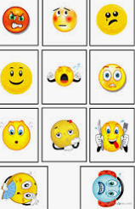
https://www.childline.org.uk/toolbox/
Use these games to think and talk about how you are feeling.
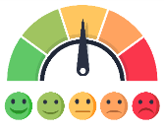
Make your own feeling barometer to show how you are feeling.

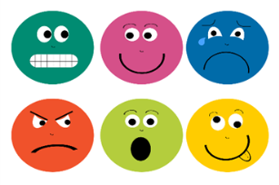
Can you make each one of these faces and name which feelings they are?
Maybe you could have a go at this with your family?

A nurse was worried about the effect that Coronavirus was having on children and how we can explain it to them in a ‘child friendly’ way. She has written a free to download story book called ‘Dave the dog is worried about Coronavirus’.
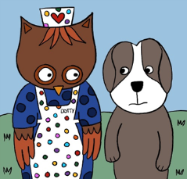
https://nursedottybooks.com/dave-the-dog-is-worried-about-coronavirus-2/
Do something you are good at and share it with your family.

Teach someone in your family to do something you are good at, e.g. drawing, playing an instrument, juggling, maths.

Enjoy colouring together with these relaxing patterns.
https://familyresource.eci.org.uk/download/Colouring-Book-for-Boys-Girls.pdf
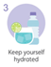 | Did you know that the recommended daily fluid intake for 5-8 yr olds is 5 glasses (1 litre) and 7 glasses (1.5 litres) for 9-12 year olds.  Measure this out into a large jug and out on the side or in the fridge. Can you empty your bottle/jug by the end of the day?  This week why don’t you try making home-made ice lollies?  Here are some ways to make them if you don’t have lolly moulds.  https://www.thekitchn.com/5-ways-to-make-popsicles-without-a-mold-220407  You can use sugar free squash or fruit juice  mixed with water, you could even  add some fruit!
Help prepare lunch or dinner for the family.
Maybe try some of the recipes from these websites.
https://www.bbc.co.uk/cbeebies/shows/my-world-kitchen
https://www.bbc.co.uk/cbbc/shows/matilda-and-the-ramsay-bunch
https://www.bbcgoodfood.com/recipes/collection/kids-cooking
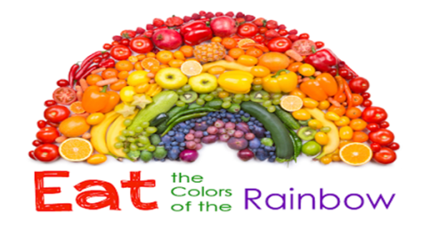
Challenge yourself to eat a rainbow. Think about the food you are eating, can you eat all the colours of the rainbow in one day?

Exeter Diocese has set up a Family Fun Cooking Club. Look at their recipes on the following link.
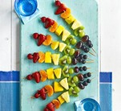
https://exeter.anglican.org/resources/faith-action/family-fun-cooking-club/

Can you make a fruit kebab?
Ask a grown up to chop up lots of different fruit and put it on a kebab stick. Which fruit will you choose? How many colours are in your kebab? Can you make a pattern with the fruit?
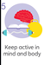 | Can you design an obstacle course in the garden?  You might use boxes, toys, a blanket, sticks, anything you can find to jump over/around/under. Can you see how many circuits you do? Can you challenge other members of your family.  Turn a walk into an exciting new adventure. Your goal is to notice as many birds, bugs, creepy-crawlies, and any other animals as you can. Anything that walks, crawls, swims, or flies is of interest, and you’ll need to focus all of your senses to find them, especially the little ones.  When you go for a walk each choose a colour and see how many of each colour you can spot.  Wild workouts with Andy.  https://www.bbc.co.uk/iplayer/episode/p06tmn51/andys-wild-workouts-series-1-1-under-the-sea  Learn to dance with Oti Mabuse  https://www.youtube.com/user/mosetsanagape  Fun dances and games  https://www.gonoodle.com/good-energy-at-home-kids-games-and-videos/
If you would like some help relaxing try this mindfulness meditation website.
https://www.cosmickids.com/mindfulness-meditation-videos-kids/

Try this technique once a day (or more) Practising it when we are not anxious, helps us to turn to it naturally when we are.
Take 5.
Hold your hand and fingers outstretched in front of you. Trace a line with the finger of your other hand up and down the outline of your hand breathing in through your nose as you go up very slowly and out through your mouth as you come down. Keep it going and repeat if you need to.

Here is a guided video to try. https://www.youtube.com/watch?v=nmFUDkj1Aq0
Play some calm ocean music on YouTube. Alternatively listen to the YouTube video https://www.youtube.com/watch?v=6If7zcLsEV4 which will take you through a guided ocean breathing meditation. Lie still and relax your body. Match your in breath through your nose to the sound of the waves, out breathe through your nose with the wave retreating. In and out, in and out holding out and in as deeply as you can. Continue for a few minutes.
Write a letter, email or draw a picture to a relative to send.

Talk to relatives or friends on the phone or video call.

Ask a relative to teach you something, read you a story or help with you school work over a video call.

Can you play a game together or sing a song together?
If you are stuck on your home learning or with your feelings ask someone for help. If you can’t put it into words write it down or draw pictures.
- Remember, it's okay to ask for help. Don't be embarrassed, and don't worry about other people judging you.
- Decide what the problem is and what help you need.
- Think about who you can ask for help. Choose someone you trust and who will know how to help you.
- Think about what you'll say when you ask for help. Do it.

Every night before you go to sleep think of three things that you have done really well that day or three things that you like about yourself. Ask a grown up to help you if you feel a bit stuck.
Keep a diary of all the positive things you do each day.
Show a family member something you have done that you are proud of.
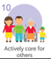 | Help in the house by doing the washing up, setting the table, tidying your room.  ‘Notice’ if someone is feeling down and ask if you can help.  Go outside of your house into your street and clap for the NHS workers on a Thursday night at 8 o’clock each week.  When you do kind things, you feel good about yourself. You get to see that what you do means a lot.

