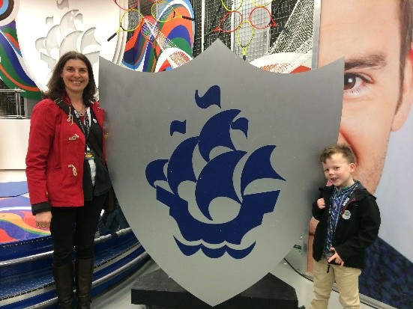
Grill a Teacher
AF: Mrs Gray what colour is your Blue Peter badge?
Hello everyone in The Hub, how are you all?

I've been asked to tell you about my Blue Peter badge. It's very old now. It's made differently to the ones they send now - it has a pin on the back a bit like a safety pin and it's made of harder plastic. I got it after I'd written to the team on the show when I was a child. I had always wanted a badge and in those days they didn't have all the different badges they do now, and it was much more difficult to get the badges. I really wanted a badge because I loved the show - I used to pretend I was one of the presenters in my bedroom - demonstrating how to make something like the presenters used to! One way you could get a badge was to be a runner up in a competition. I didn't really want to win the competitions - I just wanted a runners up badge. But all the competitions were asking you to draw something and I am not a talented artist at all! So I never got a runners up badge. So one day I wrote to the team and told them I was upset because all the competitions were linked to drawing. In response they sent me this letter and my Blue Peter badge. I was thrilled! I went out soon afterwards and used it to get in to visit The Beatles museum in Liverpool near to my home then. Do you know who The Beatles were?

My son Harry has applied for several Blue Peter badges so I've sent a photo of those too. He has a normal white and blue badge, a purple badge for sending in a review of a Blue Peter show, a green badge for Eco projects, a Sports badge, a Diamond Jubilee badge and in lockdown he's just received a Music Badge.

A few years ago I took Harry round the Blue Peter studios in Manchester because it's quite close to where my parents live. It was an amazing visit - I've attached a photo of us there too.

Let me know how your Blue Peter Badge applications are going.
With best wishes
Mrs Gray
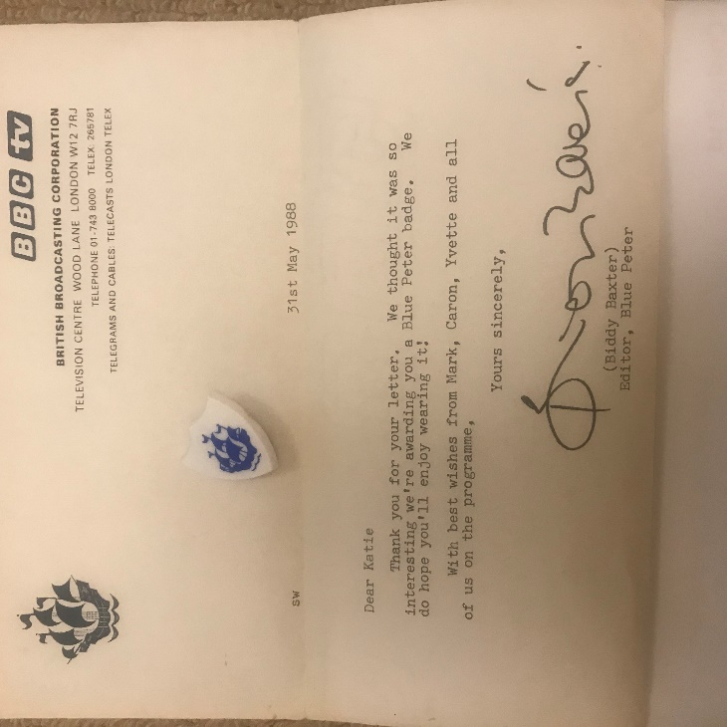
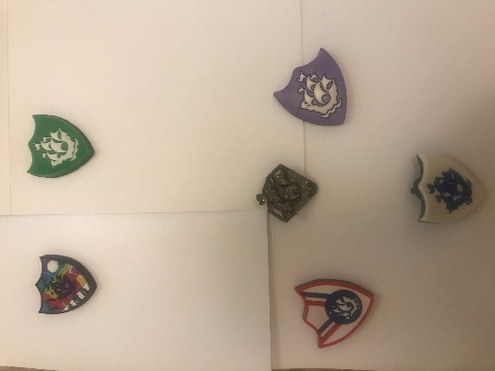
Hub Weekly Challenges 6
Week beginning 1 June 2020
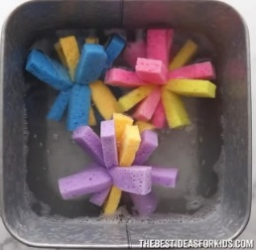  Get Building Challenge  Make some sponge balls. You will need 3 sponges and some string. Cut the sponges into 9 strips and stack them up. Tie the string around the middle and once secure, shape like the picture. Ready for summer fun! | Arty Crafty Challenge  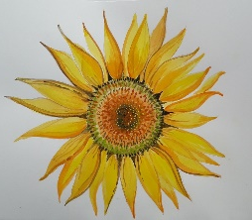  Can you draw/paint something that reminds you of summer and makes you smile. Here is my sister’s drawing of a sunflower. This definitely makes me smile!
The Tasty Challenge  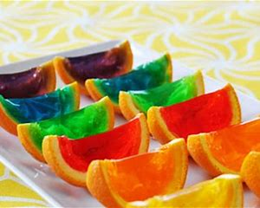  Have a go at making these jelly orange wedges!  https://www.tablespoon.com/recipes/rainbow-gelatin-orange-wedges/00611d53-f0d1-4621-adbb-1d29fda0c9fa or search Rainbow Gelatin Orange Wedges. | Keep Fit Challenge  Can you make up a 10 minute exercise class? Play some of your favourite music and ask your family to join in.
Can you find out Challenge?  Can you find out what an acrostic poem is? Can you do one using either your name or a summer theme? You can either write or type and it can be as colourful/creative as you wish. | Pass the Parcel Challenge  Continue with your stories, poems and newspaper articles. They are looking amazing! You need to write the next paragraph or verse ONLY and then email it back to me. Each week, I’ll pass the stories around….amongst the adults as well! Our writing will continue to grow!
Grill a Teacher Challenge  This week’s teacher is Mrs Padbury.  Email any questions you would like to ask her. | Your turn!  Would you like to set any of the challenges next week? Email me any of your ideas. Maybe you would like to set a Tasty Challenge or the next Keep Fit Challenge. Be creative!
I will email this out to you on a Monday. Please send me an email once a week with any of your responses, pictures etc. By Sunday 2.00pm please if you want your entries to be included. Send me an email to keepintouch@littleham.devon.sch.uk

Pass the Parcel Writing!
Harry:
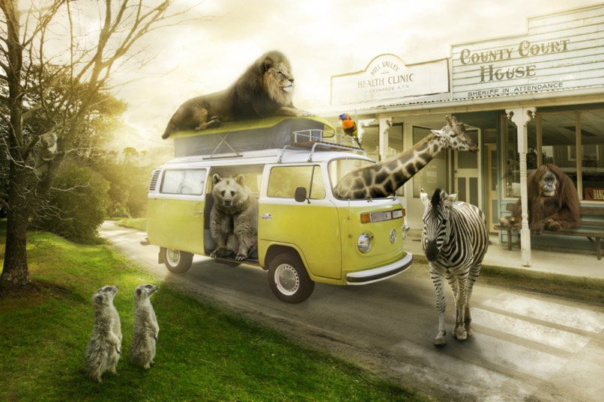
Most visitors are a little shocked (to put it mildly) when they arrive at Animal Town. Despite the fact that the name of the town gives a slight indication to passers-by that the inhabitants of the town are ‘not normal’, it’s as if people don’t believe things until they see them with their own eyes!
Once you get used to being in Animal Town – or so they say – seeing an orangutan behind a desk in a sheriff’s office and upholding the law to an impeccably high standard becomes relatively ‘normal’…
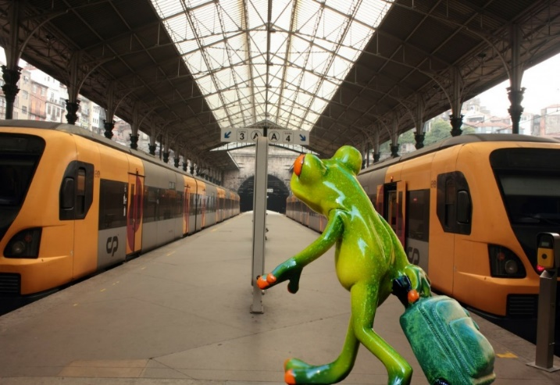
AF: There is even a train station that is run by a Rattlesnake called Lucy and her family. They help the other snakes to and from London, Zootropolis and Penzance.
GC: It is not unusual to see Zebras, in their black and white uniform of course, patrolling the streets, enforcing strict car parking measures, giving out the occasional parking ticket and obviously monitoring Zebra crossings! Don’t be fooled, these animals may look harmless and have on occasion, even been called cute, but they are feisty! There is literally nothing you can do to explain away why you had to park on the double black lines or why you decided to cross the Zebra crossing backwards. Fines and tickets are issued daily.
FMH: The local restaurant has a chef that is an Octopus as he will be able to cook a lot of things at once. The meals are served by monkeys as they can balance things well.
The school headmistress is a Mrs Whales (a small whale ) she doesn’t say a lot and stays in her office. There is a teacher called Miss Fishy, a very quiet fish, that is not too clever and forgets what she has said very quickly.
SH – The thing is, this Animal town appears relatively ‘normal’ of a day (once you get used to it of course!) Orangutangs behind desks, zebras handing out parking tickets, snakes running train stations, tigers riding bikes, cats being the best hair dressers in town and even the elephants have got their nail salon set to up to perfection. So good, their awarded best in town each year! The list really does go on, but what the visitors of Animal Town do not know, is that things drastically change of a night time. I mean, did they not tell you the Animals become humans when the sky is dark?!
At night the animals turn to humans so they can sleep in comfy beds.
KJ: They sleep for an hour, re charge, and then it's time to party.

Although now humans, you can still tell which animal they will turn back into once the sun comes up. The Zebra is now a black and white striped human, the Tiger an orange, black and white striped human, the Grey human who was an elephant an hour ago, he likes to have an extra half hour sleep in the comfy bed.

They all gather in the restaurant which chef octopus has transformed into a spectacular disco. There's a buffet, (although now humans, they still like their own animal food) there's music, there's singing and there is LOTS of dancing. Oh they do love this part of the day.

But when the clock strikes 3am, that's when the magic begins.....

Mrs Jones:
There was an old man with a beard
Who said, “It’s just how I feared!
Two owls and a hen
Four larks and a wren
Have all built their nests in my beard

JC -There was a silly old cat,
He wore a coat, some gloves and a hat,
He ate all day long,
To be big and strong,
But ended up very fat!

A young witch called Nellie,
Made potions that were smellie,
The spells were not right,
As she was not bright,
And she ended up with a sore belly!

GC- There was an old teacher indoors,
Who had no children just chores,
She wanted to teach,
Get away from the bleach,
But she just kept cleaning the floors!

SH - ​There was an old hedgehog who was very slow,
But in the garden, beautiful flowers are starting to grow,
The hedgehog often sunbathed, he liked the suns glow,
The grass is so long it’s definitely ready to mow!
Must remember the vegetable seeds are set to sow,
If you see a dandelion, don’t forget to make a wish and blow!

Freddie: There was a young boy called Fred
Who liked to stay in bed
On his birthday in May,
was going to sleep all day,
but got up and played games instead.

Freddie:
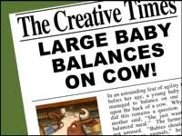
Yesterday, locals in the village of Hamlittle were shocked to see a giant baby sitting on a cow in a field that belonged to Farmer Jack McDonald (postcode , ei ei o).
Concerned for the baby's wellbeing, a local girl-Miss Muffett called the authorities and contacted us at the Fabled Times. Constable Dick Wittington was quick to attend the scene and deal with the situation. On speaking to Farmer Jack he was able to establish that there was no cause for concern as Jack informed him that the Beanstalk had grown back and that the baby belonged to the Giant family who lived in a castle in the clouds and they often came down to visit Jack and meet the cow that had brought the two families together. Mrs Giant was very positive about the friendship and said, " Although we are from different backgrounds, we get on famously.” Reporter: Jacqui Clark

Alex reports that the giant was killed when the beanstalk was chopped down were false and he also does not like to grind people’s bones to make his bread. It appears that Jack made up these stories so he would not get told off for stealing the magic harp and the hen by his mum.

GC -Witnesses in the village of Hamlittle report that Miss Muffett felt so guilty for having got the police involved, so took Farmer Jack a sack of seeds, some curds and whey and a bottle of his favourite cider to say sorry. Jack apparently was taken aback by this surprising show of kindness and was seen to blush rather red…..Miss Muffett is considered to be rather beautiful!! Eyewitnesses say that while Miss Muffett was sitting on a bale of hay admiring Jack’s recently planted fields, a rather large spider caused Mabel Muffett to scream. Farmer Jack, leapt to her rescue rather heroically and is now seen as the local hero. Mabel has been seen since often taking her daily walk in Jack’s fields!

SH – Farmer Jack is the only hero the village has ever had! He’s become Hamlittle’s most famous farmer, so much so that witnesses have reported that press are hiding behind Bill and Ben’s flower pots, waiting to capture their next snap of him! It’s been said that Little Bo Peep now keeps all of her sheep in Jack’s field so Miss.Muffett can no longer walk through! Later that evening, Humpty Dumpty told the press he witnessed Farmer Jack, down on one knee, holding a little silver box out to Miss.Muffett, but as the box was about to be opened, Humpty fell off the wall and didn’t get a chance to see what was in it after all!

Miss Hitchcock
I wish there was a law that said………

KJ: That adults aren't in charge of children 7 days a week.
For one day, children have free reign. They can choose what they want to do, and where they want to go, and the adult must adhere to the rules!

JC: That when it’s your birthday you can have a day of school/work and everything is paid for. You could take a day trip anywhere. Eat what you want and everyone you meet greets you with a smile and sings ‘Happy Birthday’!

Freddie and Forest school friends:
- All public transport over the whole country to be free for people over 70.

- Litter dropping especially plastic is to be fined. 1st time £ 110. 2nd time £ 310. 3rd time £ 1000. 4th time -1 month in prison

- Eating egg sandwiches in confined spaces to be banned.

- All students up to age 18 should have free public transport during term time.

Alex: I wish School were optional and if you did have to go discos are a must every day.
I also wish you could eat all the sweets you want without the consequences.

GC: 1. People aren’t allowed to talk in the cinema during a film! (Mr Cambridge)
2. You can respawn at any time (Joshua)
3. The sun won’t go in when I sunbathe! (Joshua)
4. The sea will always be warm when I swim in it. (Mrs Cambridge)
5. Cars will keep 2m away from me when I ride my moped! (Samuel)

Mrs Cambridge:
In six days there will be no more chocolate in the world….ever! That’s what it said on The Seven Show. Jelly had nearly reached the next level of Zombie Puppy Dash, but hearing this made her plunge the pink puppy into a huge tank of zombie dog food. “Woah! What was that about chocolate….”
KJ: Jelly could not believe what she was hearing! How can this be?! Chocolate is Jelly's most favourite thing in the world (closely followed by Zombie Puppy Dash)
Jelly dreamed that one day she would own a chocolate shop, filled with all of her favourite bars; Crunchie, Twirl, Lion, Milkybar, Mars bar, to name a few. A chocolate bar Buckingham Palace to attract the customers, but now Jelly will have to think of a new dream...........
Jelly had to start the level of Zombie Puppy Dash again, and Jelly better eat chocolate for breakfast, lunch, and dinner for the next six days.
JC: Jelly began her new plan the next day. Chocolate was the priority though and she was going to make a big start right now for breakfast: Chocolate pancakes with chocolate spread, chocolate dip ( for a few strawberries) and a large chocolate milkshake , “yummy yummy “.
After such a delicious start to the day Jelly did wonder if she had eaten too much chocolate and would there be enough for the next 6 days?
What was she going to do? No more chocolate FOR EVER!!
Could she make some? No
Could she grow some? No
Was there anything that she could have instead that tasted as fantastic as chocolate? Probably not.
She sat down in a gloomy mood and decided to play her game to cheer herself up. The Pink Puppy was so clever making it through the tricky Zombieland zones getting a special treat when a level was completed. Then the idea came to her-" I’ve got it , I know what I’m going to do “......
AF: Then Jelly remembered not everyone liked or could eat chocolate and she did like chewy skittles and so would open a sweet factory run by wind power, but to do this she would need...
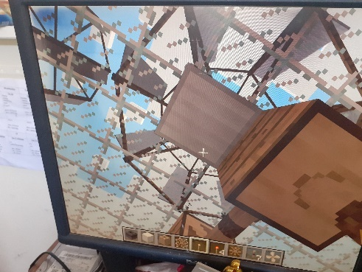
(picture of Jelly's factory in minecraft)

Alex:– you can add to either of the diaries below
Dear Diary,
Today, the doorbell rang, and I eagerly ran down the stairs. By the time I had opened the door, the delivery driver had vanished, but a giant box had been left on my doorstep.
​SH - The box was too heavy to lift and too big to get through the door. I opened it to find a smaller box inside, covered in chains and padlocks. A note was stuck on the top that said ‘this box of secrets has been hidden for hundreds of years. Look closely and follow the clues’
I sat next to the box for a while, reading the note, wondering how I was going to solve this mystery. A white feather with two black spots on fell from the sky and landed on my foot. I picked it up and looked at it closely. Was this my first clue?
HT – The feather had a note attached to it. It said, “The next clue is somewhere you can find a feather.”
So we went to a chicken coop to see if we could find it. To my astonishment, the clue was glued onto the chicken. Before I could read it, I had to catch it. The chicken flapped everywhere dropping feathers all over the place until I spotted a bag of seeds. I put the seeds into a box and the chicken fell for my trap. I caught it with a net. The note said,
“You will find it where every animal goes to drink. It’s not the river”
So we went to the watering hole and I was amazed. The loch ness monster had the note taped to his back. I took all my clothes off and went for a swim. I grabbed hold of his tail and he shook me like a rag doll but I managed to climb onto his back and have a ride. I got the note and rode back to shore and ran away as fast as I could.

JC: After drying myself and getting some warm clothes back on, I read the note. Your next clue is –“A note on the door of Littleham Church will help you further with your search.” So off I set on the long journey from Loch Ness back down to Exmouth, thinking when would this mystery be solved and what was in the box of secrets? Was it gold coins from pirates or was it a device to help with time travel? I was so excited to find out and hoped it would be soon.
On arrival at the church, I saw the note with yet another clue!
“Look for a beast with a note in its claws-a dinosaur with massive jaws"

OR
KJ - Dear Diary,
Today, the doorbell rang, and I eagerly ran down the stairs. By the time I had opened the door, the delivery driver had vanished, but a giant box had been left on my doorstep.
What had I ordered during this lockdown period??
I opened the box and inside that a smaller box - wrapped in yellow and pink polka dot paper, but it was empty.....
I opened that box, to find an even smaller box - wrapped in green and blue polka dot paper, again the box was empty.....
I was wondering why all these boxes were empty, but as I looked again I saw a small package. I opened it to find a small frame which read "True friends are never apart, maybe in distance but never in heart"
This made me smile...........

Mrs Clark – you can add to either of the stories below
Bleary-eyed, I went downstairs for breakfast, the house was empty, even the furniture had gone.
GC -I rubbed my eyes. Am I dreaming? But as my eyes adjusted to the morning light creeping in through the slits in the curtains, I realised this was no dream. What was happening? Walking around, in a shocked daze, I noticed dents in the carpet where the furniture had been. There had sat my favourite rocking chair with my fluffy purple cushion; over there had lived my piano with one key missing and beyond had stood my slightly faded sofa. Suddenly, a chill ran down my spine, and turning sharply, I thought I noticed a slight scurry of movement in the corner of the room.
SH: As I turned, the piano key flew across the room and the piano started to play. What on earth was going on? I rubbed my eyes again, I couldn’t quite believe what I was seeing. I crept across the squeaky floorboards towards the piano key that was dangling in front of the living room window. As I reached out to get it, it flew straight past me and up the stairs. Now I really was nervous, but I slowly crawled up the stairs, following the piano key. It led me to the bathroom, but my bathroom was no more, there in front of me, was a spiralling circle, whizzing around so fast I went a bit dizzy! I sat on the floor, the piano suddenly stopped and a whispering voice said ‘Crawl through the whizzing tunnel, your adventure is about to begin’.
OR

Bleary-eyed, I went downstairs for breakfast, the house was empty, even the furniture had gone
KJ: I quickly went to look around the house to see if I could find any clues as to what had happened? Where had everything gone? I went into the kitchen and a cupboard door was open, so I peered inside. Sat on the shelf, was an old wooden box. I took it out slowly, it was quite heavy. The top of the box read 'Carnival Of Colour Open To Play'
I took the box into the empty living room to open it. It was a board game. Inside were two dice, two rainbow coloured counters, and a start to finish shaped like a snake.
Nervously I picked up the dice and rolled them onto the box.... 7. I moved one of the rainbow coloured counters 7 spaces.....then there was a huge puff of red, yellow, green, blue, orange smoke that filled the whole room. I couldn't see anything. As the coloured smoke settled I looked around, I wasn't in my living room anymore. I was in a forest surrounded by the most colourful trees and the board game next to me, which now read 'roll to play again'.........
HT: I rolled again, and I was in the world of Star Wars. I appeared in a spaceship. When I looked outside, there was chaos. A massive space battle was going on. Then I looked in the corner of the battle and I saw another portal. I think it was to get out of here. I realised the only was through the portal but how was I going to get there? I looked behind me and saw armour that would help me breathe in space. Now the only question was how to get to the portal without being blown to bits. Then, I saw a landed spaceship nearby and it looked like it had bullet proof armour so I hoped in and flew to the portal.

Hub Exhibition

w/b. 20.4.20 Alex’s bottle rocket, carrot cake and proudly wearing his new Blue Peter badge which arrived this week. FANTASTIC!
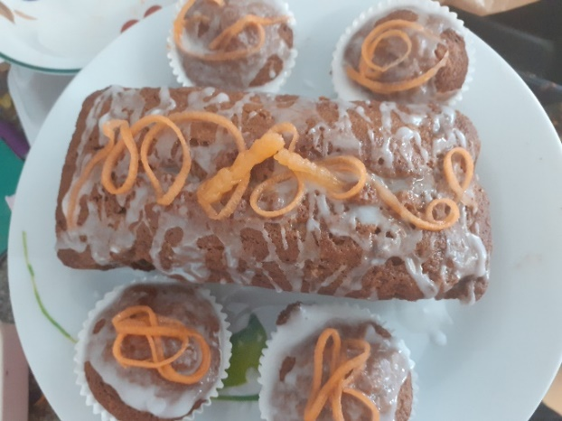
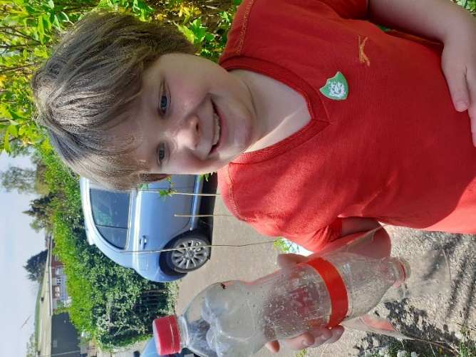
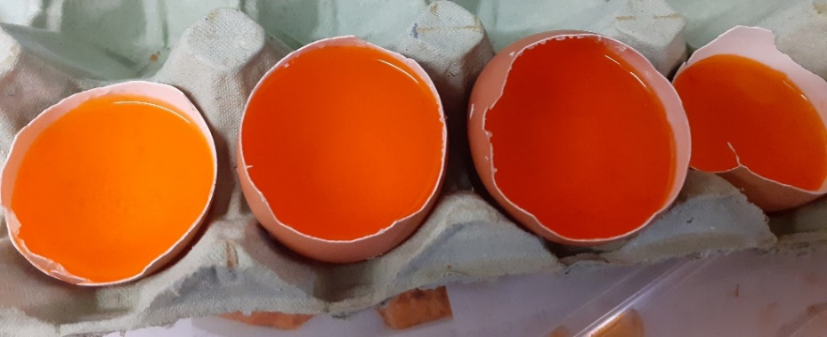
w/b. 27.5.20
Alex started to make his crystal geode eggs.
These look exciting! Can we have a picture once they have crystalised?

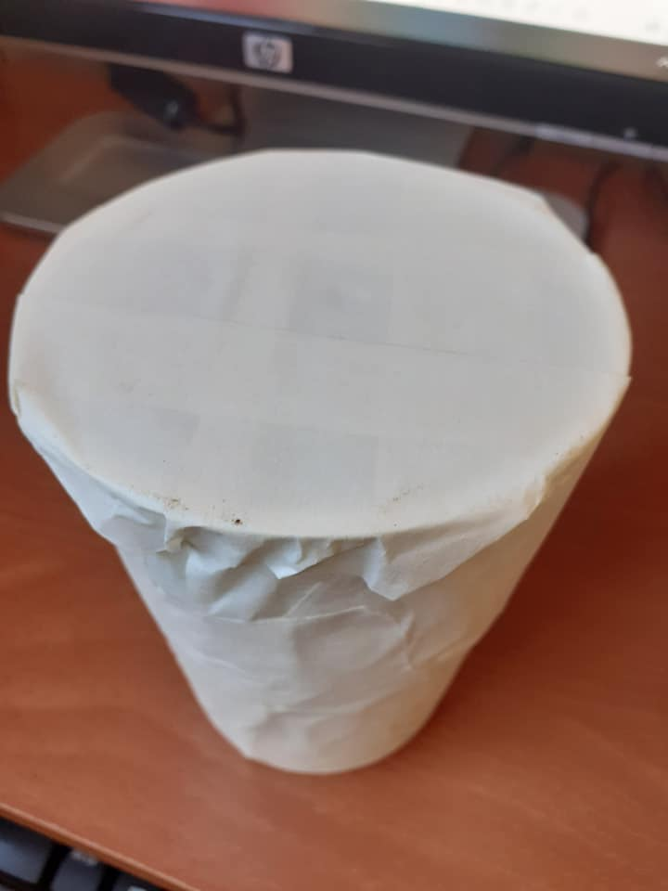
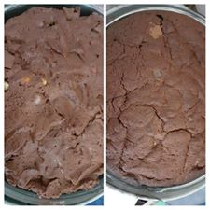
w/b 4.5.20 Alex’s chocolate concrete -before and after baking

Yoghurt pot drum
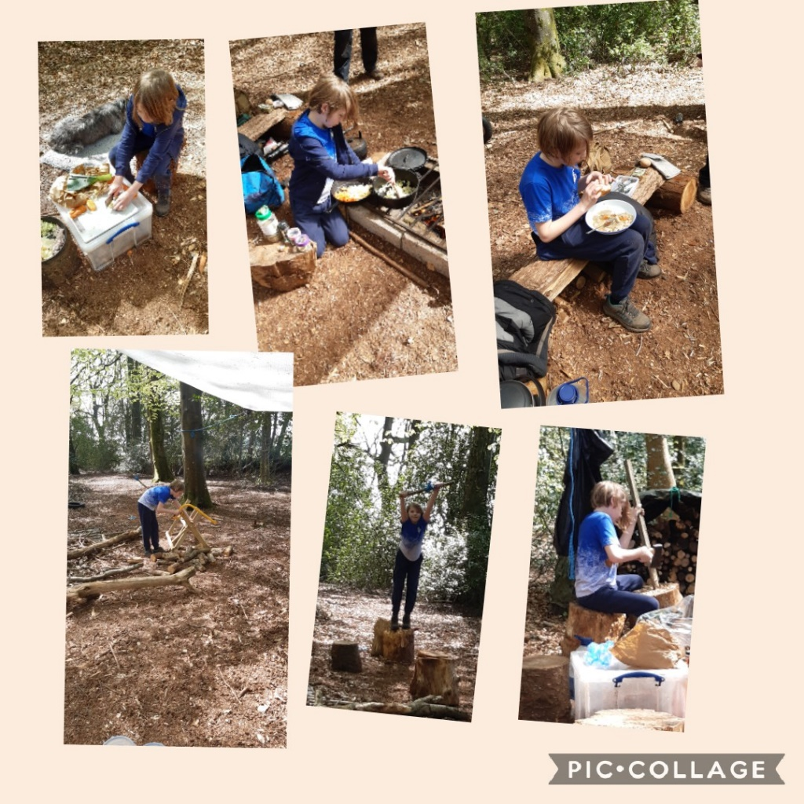
Fun at Forest school! That food looks delicious Freddie!

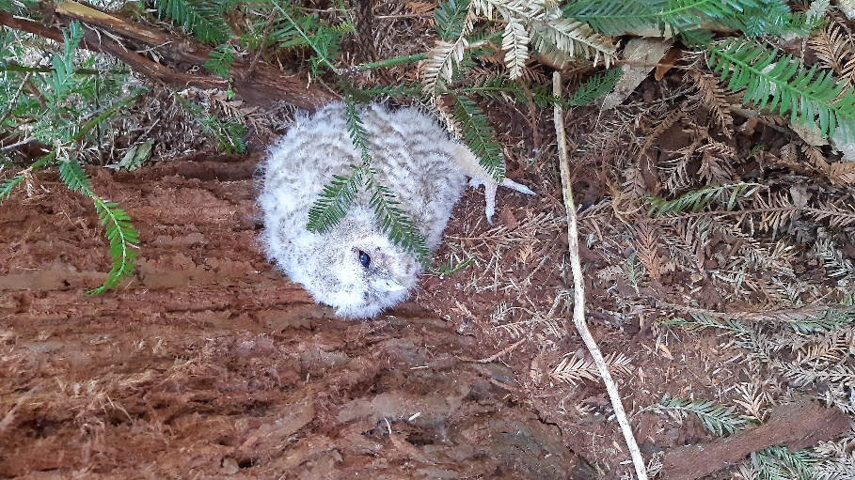
Beautiful baby tawny owl seen at Forest school -I bet you wanted to take it home with you Freddie!

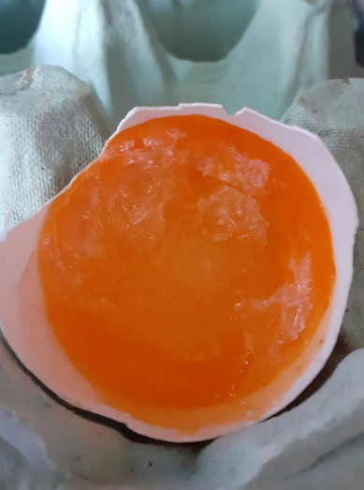
Alex Goode egg update…beginning to crystallize.

w/b. 11.5.20 Alex’s Lemon volcano
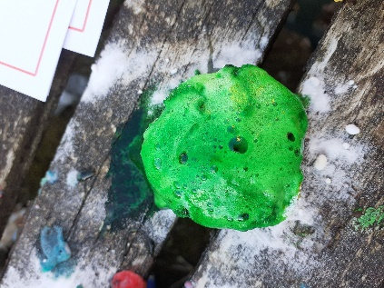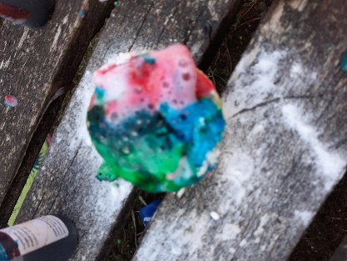
We tried lime and orange
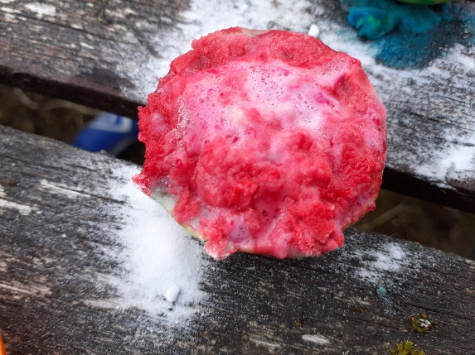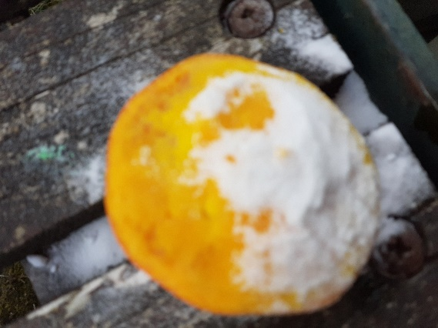
Out of the three Lemons worked the best
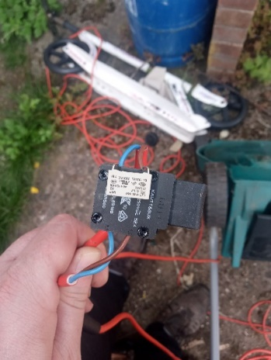
Mrs Gibson dropped an old lawn mower off for Alex to take apart he needs to tell her 6 things about it. This looks exciting Alex….I look forward to hearing all about it!

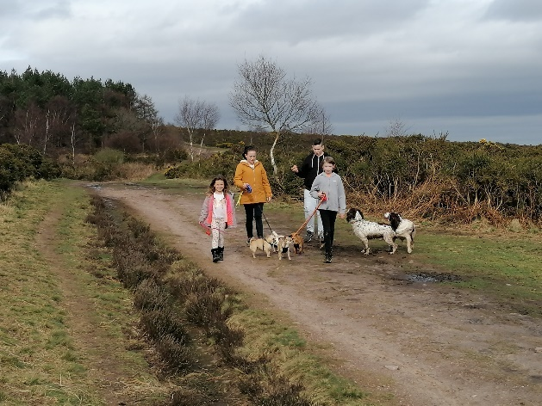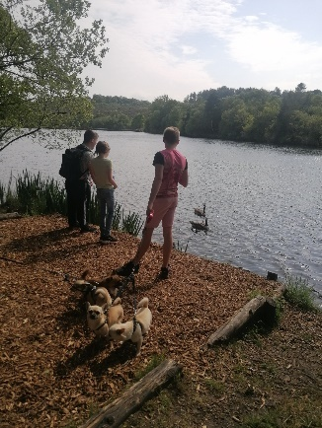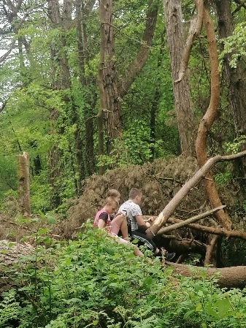
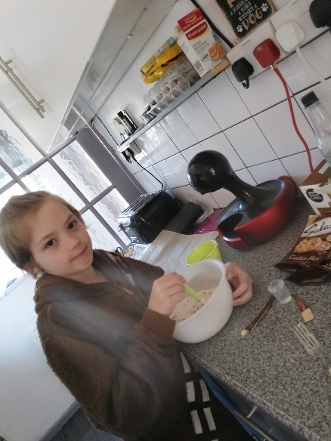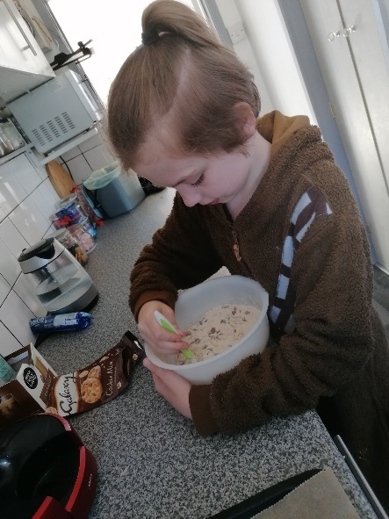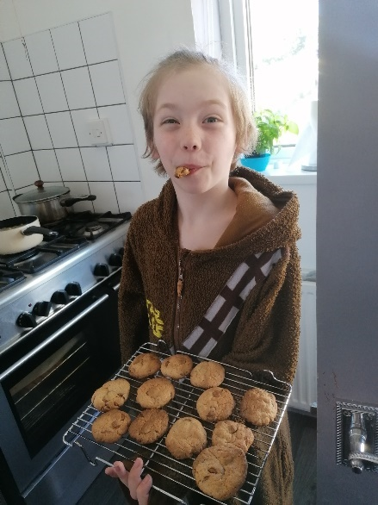
These cookies look delicous Freddie……how many did you eat?
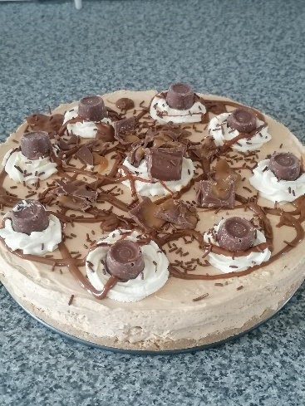
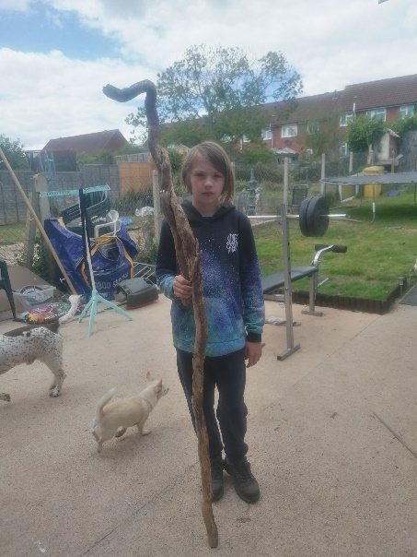
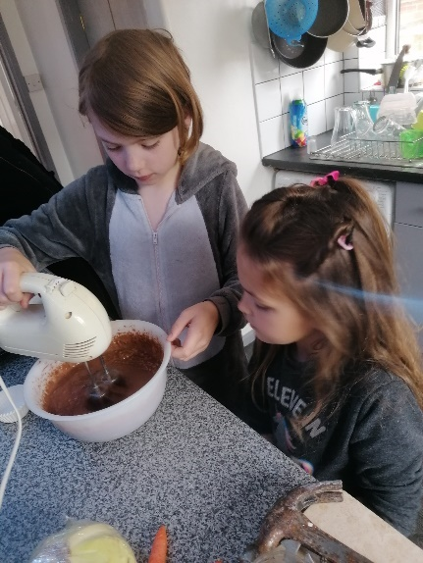
Mrs Clark – I heard you had a cheeky slice of this Rolo cheesecake?!!!
Wow! That’s bigger than you!
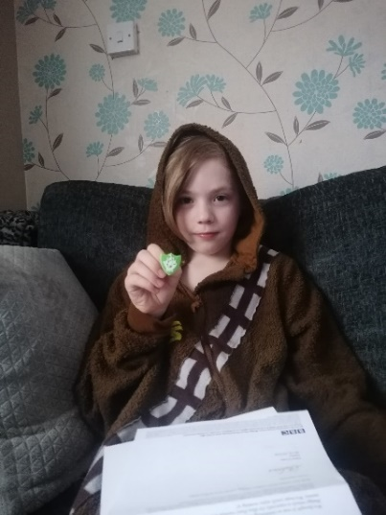

Freddie’s Blue Peter badge arriving!

Freddie and his mum write “A few of our adventures. We take dogs to the common most days we hunt for good wood and sticks build dens and have fun with the dogs. I have enjoyed making cookies cakes and a Rolo cheesecake. On my walk I have carved my name in a fallen big tree. Found a stick that has a handle on. I have my Blue Peter badge and enjoy forest school on Wednesdays. Outdoors is my favourite in the trees and quiet places.”
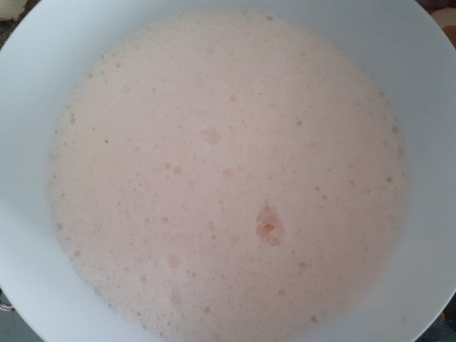
w.b. 18.5.20 Alex making Jelly Fluff!
I hope it tasted as good as I remember Alex!

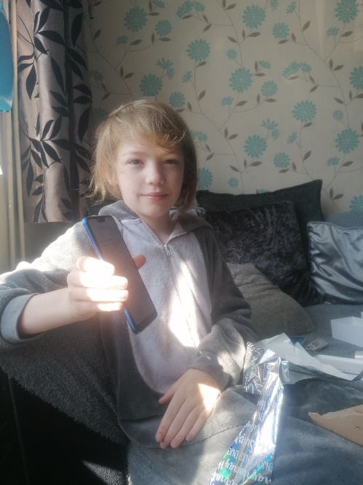
Freddie had a lovely day (birthday) he loved the card from you all and giggled at some comments.
He is happy with new phone and chair.
He made homemade pizza and was great and kneading the dough and pizza went down lovely.
Amy Hall
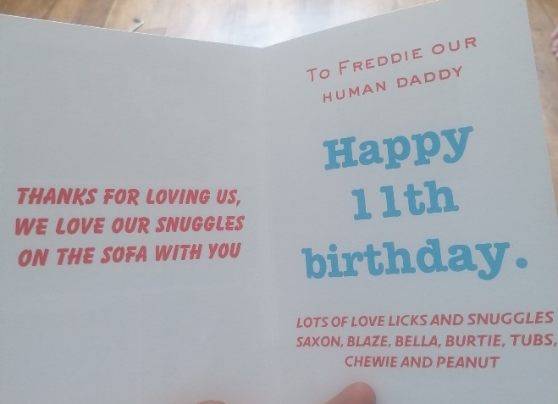
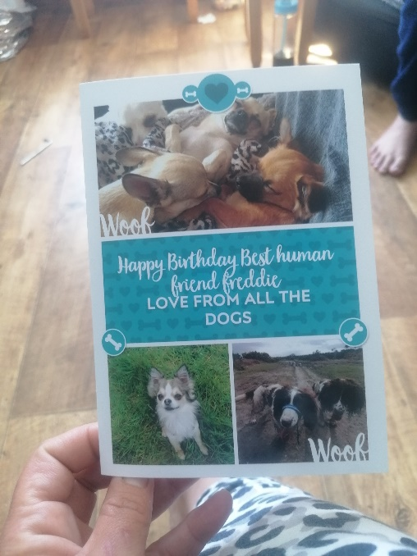
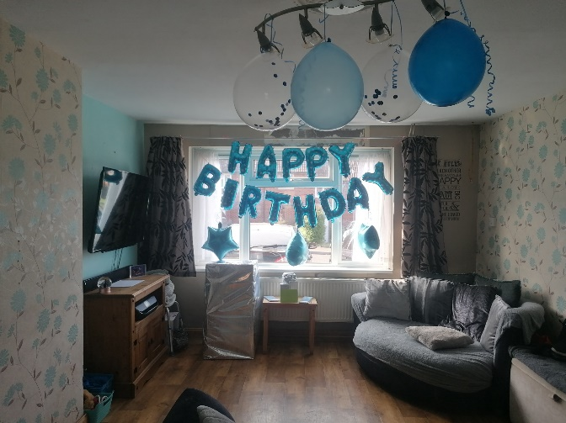

I’m loving this card Freddie….what clever dogs!

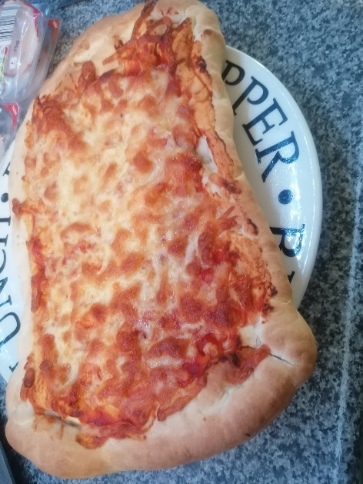
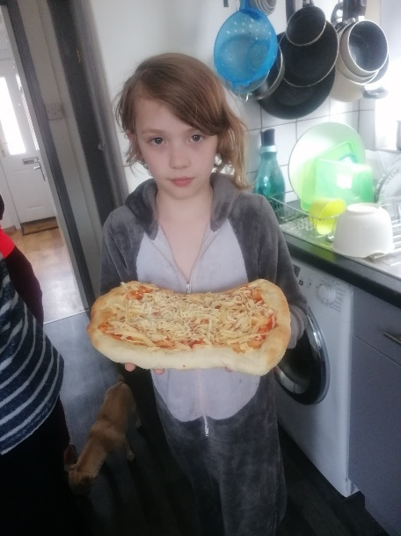
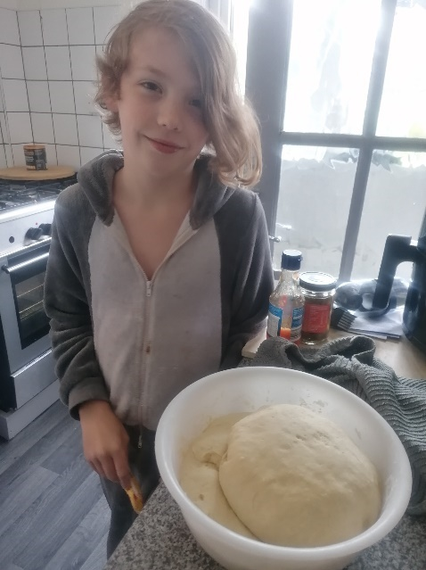
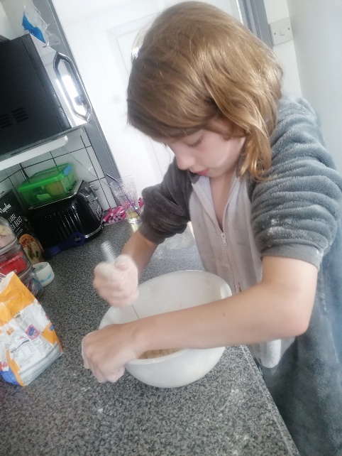
I’m so impressed you made the pizza dough for this pizza….it looks delicious! Where’s my slice?
