Year 3 Learning from Home Grid

Week Beginning 1.03.21
This week, our learning behaviour is reasoning.

Think through your ideas. How can you solve a problem in a clear and orderly way? Squirrels are clever animals who can work out how to get a food source even when it is not an easy task.

If possible, please email me with examples of your child showing reasoning.
 | Please be aware that your home filter may allow unsuitable links to pop up when watching any YouTube videos
www.getepic.com.students
Use this website to read free digital books suitable for your child.
I will add some of the books to google classroom.
If you want to explore further, click on AR and choose the numbers at the back of your child’s reading record book.
Monday 1st March 2021 | Reading (30 minutes)  - Complete this week’s reading comprehension assignment by reading the text through and answering the questions on the quiz.  - You can read a book on bug club, your current book from the library or you can read a book of your own.  English (1 hour)  LO: I can choose a creature of object and a main heading for my final page.  See instructions for Monday.  Collect A3 page from school if needed to be used in English lessons this week (not for notes)  Please take a photo and email it back to me at Y3Teacher@littleham.devon.sch.uk  I would also like you to send me the paper sheet when you pick up your next pack next week.  Maths (1 hour)  LO: I can solve division word problems.  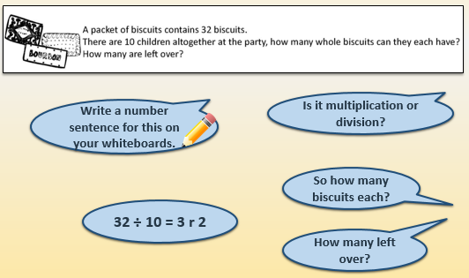  Please complete the allocated work sheet I have sent to you in your home pack or on google classroom. Remember the working out method is just as important as the answer. Please take a photo and email it back to me at Y3Teacher@littleham.devon.sch.uk  I would also like you to send me the paper sheet when you pick up your next pack next week.  Science (1 hour)  https://classroom.thenational.academy/lessons/how-can-we-see-objects-6ct6ct  LO: I can understand how we see objects.  Have you ever wondered how our eyes are able to see things? In this lesson, we will be learning how our eyes are able to see different objects. We will find out how light travels from a light source to our eyes and what happens when it reaches the eye. You will need a piece of paper and a pencil.  PE with Joe (30 minutes)  https://www.youtube.com/watch?v=-yI7PU5Sxj0
Tuesday 2nd March 2021 | Reading (30 minutes)  - If you haven’t already, please complete this week’s reading comprehension assignment by reading the text through and answering the questions on the quiz.  - You can read a book on bug club, your current book from the library or you can read a book of your own.  English (1 hour)  LO: I can research useful facts for my final page.  Please take a photo and email it back to me at Y3Teacher@littleham.devon.sch.uk  I would also like you to send me the paper sheet when you pick up your next pack next week.  See instructions for Tuesday.  Maths (1 hour)  LO: I can find pairs of multiples of 5 that total 100.  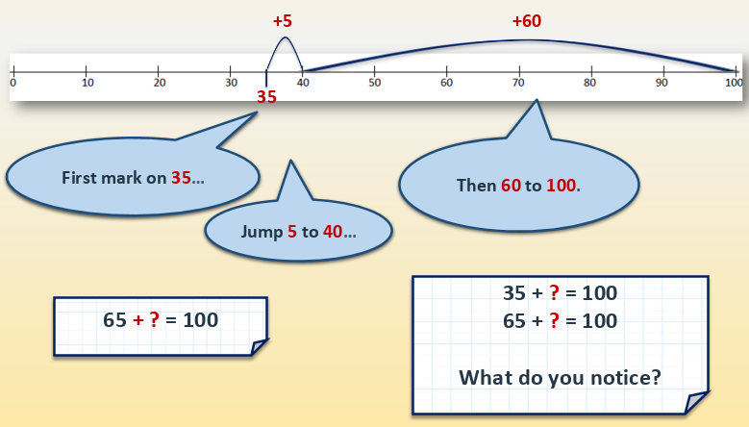  Please complete the allocated work sheet I have sent to you in your home pack or on google classroom. Remember the working out method is just as important as the answer. Please take a photo and email it back to me at Y3Teacher@littleham.devon.sch.uk  I would also like you to send me the paper sheet when you pick up your next pack next week.  RE (1 hour)  LO: I can understand the importance of the Shabbat to Jewish people.  Think about parties and celebrations you have been to. What was being celebrated? Why did the celebration take place? Who was it for?  Make a list of celebrations & sort them into religious celebrations and non-religious celebrations. What are the differences and similarities between the two different types of celebrations?  Which celebrations:  - Remember a story?  - Are celebrated by everyone?  - Raise money?  - Share food exchange gifts?  - Remind people of beliefs and values?  Watch the video showing a family preparing for Shabbat e.g. http://www.bbc.co.uk/programmes/p0114f7y  Collective Worship (30 minutes)  Please log into you Google classrooms account to view the Collective Worship from Mrs Padbury.
Wednesday 3rd March 2021 | Spelling(30 minutes)  https://classroom.thenational.academy/lessons/to-practise-and-apply-knowledge-of-suffixes-past-and-present-tense-including-a-test-61h3ce  LO: I can practise and apply knowledge of suffixes: Past and present tense, including a test  In this lesson, we will practise the rules associated with adding the suffix -ed. We will learn how to practise using the small to large strategy and will test the words previously set to learn.  English (1 hour)  LO: I can write the main heading and introduction for my final page.  See instructions for Wednesday.  Please take a photo and email it back to me at Y3Teacher@littleham.devon.sch.uk  I would also like you to send me the paper sheet when you pick up your next pack next week.  Maths (1 hour)  LO: I can find pairs of multiples of 2 that total 100.  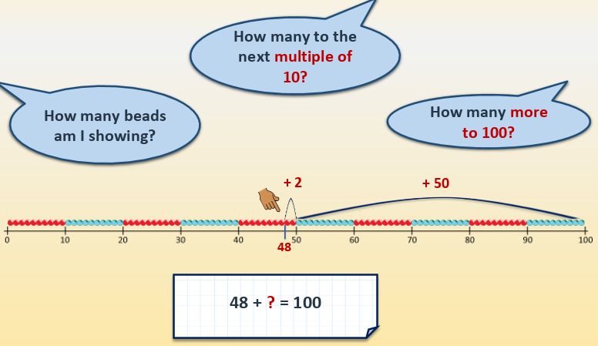  Please complete the allocated work sheet I have sent to you in your home pack or on google classroom. Remember the working out method is just as important as the answer. Please take a photo and email it back to me at Y3Teacher@littleham.devon.sch.uk  I would also like you to send me the paper sheet when you pick up your next pack next week.  Art (1 hour)  LO: I can draw, paint or photograph an urban landscape (Exmouth).  Learn how to use a digital camera or tablet (including the zoom function) to take close up photographs of patterns and shapes found in an urban landscape. Take photographs from unusual viewpoints, such as from underneath, above and between different objects. Look for patterns on drain covers, windows, bricks, graffiti, stone work, glass, sculptures, plaques and paving. Email photographs to my email address. If you do not have access to a camera, you can draw or paint patterns and shapes found in the urban landscape.  PE with Joe (30 minutes)  https://www.youtube.com/watch?v=qoh7OnG2K_0
Thursday 4th March 2021 | Reading (30 minutes)  - If you haven’t already, please complete this week’s reading comprehension assignment by reading the text through and answering the questions on the quiz.  - You can read a book on bug club, your current book from the library or you can read a book of your own.  English (1 hour)  LO: I can design my layout and begin writing my final page.  See instructions for Thursday.  Please take a photo and email it back to me at Y3Teacher@littleham.devon.sch.uk  I would also like you to send me the paper sheet when you pick up your next pack next week.  Maths (1 hour)  LO: I can find the difference between a 3-digit number and a 2-digit number by counting up.  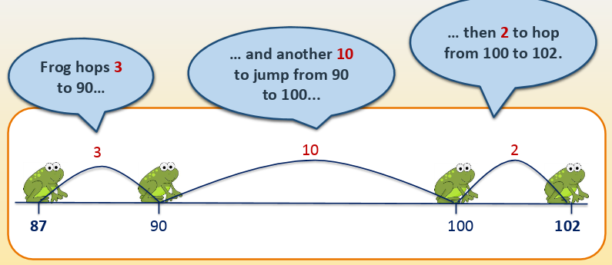  Please complete the allocated work sheet I have sent to you in your home pack or on google classroom. Remember the working out method is just as important as the answer. Please take a photo and email it back to me at Y3Teacher@littleham.devon.sch.uk  I would also like you to send me the paper sheet when you pick up your next pack next week.  Geography (1 hour)  https://www.youtube.com/watch?v=ReW4MPqXTvA  LO: I can analyse primary data, identifying any patterns observed.  I carried out a survey amongst staff to find out how they travel to work. I have put the results (data) into a simple table. I would like you to analyse the data and display it in a bar chart. Watch the video to help you draw a clear and accurate bar chart. Use your bar chart to answer the questions I have asked about the data.  PSHE ( 30 minutes)  https://classroom.thenational.academy/lessons/help-is-on-hand-cgtpat  Help is on hand  In this lesson, you will be able to identify the people who help the local community. You will write a letter thanking them for their help.
Friday 5th March 2021 | Reading (30 minutes)  - If you haven’t already, please complete this week’s reading comprehension assignment by reading the text through and answering the questions on the quiz.  - You can read a book on bug club, your current book from the library or you can read a book of your own.  English (1 hour)  LO: I can complete my final page in the style of ‘Dare to Care’.  See instructions for Friday.  Please take a photo and email it back to me at Y3Teacher@littleham.devon.sch.uk  I would also like you to send me the paper sheet when you pick up your next pack next week.  Maths (1 hour)  LO: I can find the difference between a 3-digit number and a 2-digit number by counting up.  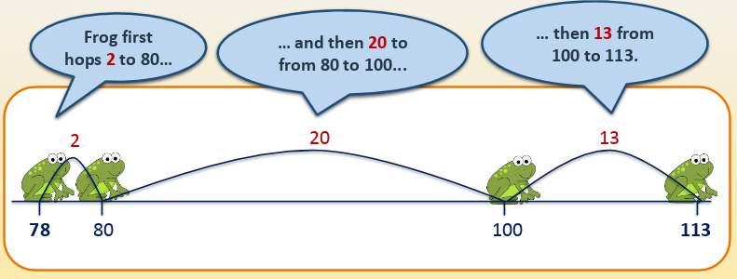  Please complete the allocated work sheet I have sent to you in your home pack or on google classroom. Remember the working out method is just as important as the answer. Please take a photo and email it back to me at Y3Teacher@littleham.devon.sch.uk  I would also like you to send me the paper sheet when you pick up your next pack next week.  Mental Health (30 minutes)  See google classroom for this week’s activity.  History (1 hour)  https://exmouthhistory.co.uk/category/exmouth-history/  https://www.visitexmouth.org/history/  LO: I can conduct a local history study.  Use the websites to research the history of Exmouth. Make an information poster to show what Exmouth used to be like. You could use the sub-headings: Shops, Beach House, Exmouth’s Oldest Buildings, Exmouth Railway Station and one other of your choice. Draw pictures, write facts, give dates.

