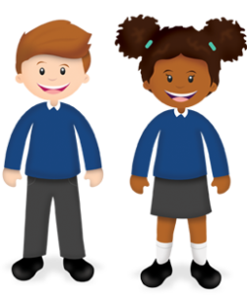
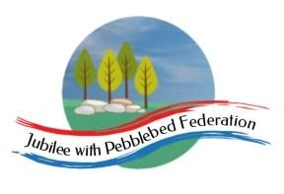
Year 1
Learning from Home

Year:  Week beg:  08/3/2021 | Lesson One | Lesson Two | Lesson Three | Lesson Four
Monday | Maths and Art.  Identify and represent numbers sing objects – team treasure hunt. | English and Art  Listen to a story. Use colour to show how a monster is feeling. | Reading  Log in to Bug Club and read a book from your ‘library’. https://www.activelearnprimary.co.uk/login?c=0  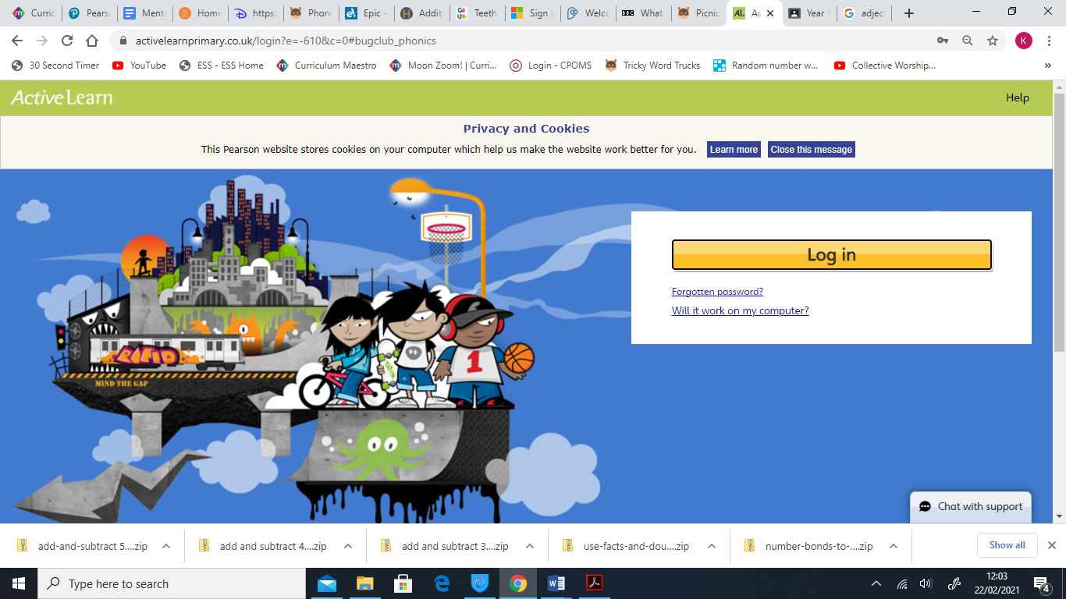 | Phonics  Recap of phase 3,4 and 5 sounds, all phase 3,4 and 5 tricky words and alien/real words.
Tuesday | Maths and PE – Add 2 or 3 numbers – Number track activity. | English and Drama  Recognise how someone is feeling. Create role play situations to show how a character is feeling.
Wednesday | Maths and DT  Use language to compare height – team tower sculptures. | English, Music and PE  Know different words to describe feelings. Move and dance to different kinds of music.
Thursday | Maths and Art  Count in 2s, 5s and 10 and describe a number pattern – spiral number snakes.  Maths, Art and Music.  Represent and use number bonds within 20 – fishy art. | English and DT  Identify the moods of monsters in a story. Make a model of a monster in a particular mood.
Friday |  | English and Art  Write a letter to a monster. Suggest ways to cheer up a sad monster.

Please be aware that your home filter may allow unsuitable links to pop up when watching any YouTube videos.
How have you worked like a Parrot this week? Send me a photo for our display at school!

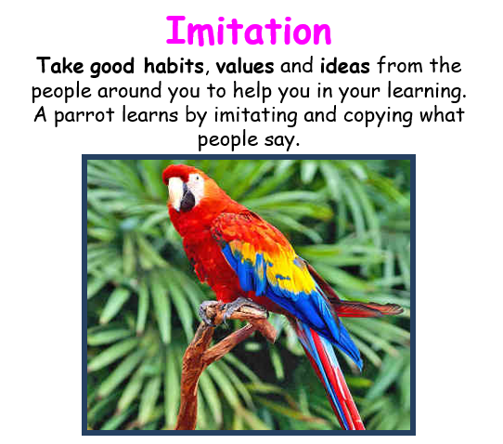

__________has behaved like a ‘Parrot’ at home by…..

