Year 5
Learning from Home

Year:  Week beg:  19/4/2021 | Lesson One | Lesson Two | Lesson Three | Lesson Four
Monday | PE  Get your heartrate up! Try some PE with Joe Wicks  https://www.youtube.com/watch?v=WhnRJbSNyfM | English  https://www.youtube.com/watch?v=TbQSdapmALw  Listen to the story of Weslandia and then complete the likes, dislikes, puzzles and patterns grid. | Maths  Multiples and Factors  https://classroom.thenational.academy/lessons/multiples-and-factors-6gr32d | PSHE  Eat Well Live Well https://classroom.thenational.academy/lessons/my-own-workout-75j6at
Tuesday | Spelling  Silent Letters  https://classroom.thenational.academy/lessons/to-investigate-silent-letters-c9gk4r | English  Read the story of Weslandia. What do you think is the message the author is trying to give the reader? Write the message you think that the author is trying to give down explaining why you think this is the message – you may even have more than one! | Maths  Using mental strategies to multiply (factors)  https://classroom.thenational.academy/lessons/using-factors-to-multiply-6wtp4r | PE  Try some Yoga!  Cosmic Kids – https://www.youtube.com/watch?v=VWIt7mVwbD0
Wednesday | Spelling  Silent Letters  https://classroom.thenational.academy/lessons/to-practise-and-apply-knowledge-of-silent-letters-including-test-6mvkjc | English  Choose your favourite part of the story. You are going to learn this part to retell – draw a story map to help you and then learn it! Tell it to someone at home or keep it safe to tell to me when you return to school. | Maths  Using mental strategies to divide (multiples)  https://classroom.thenational.academy/lessons/using-multiples-to-divide-6cw3gd | Art  Look at any plants, fruits, vegetables or flowers that you have at home. Sketch them carefully and then colour them using coloured pencils.  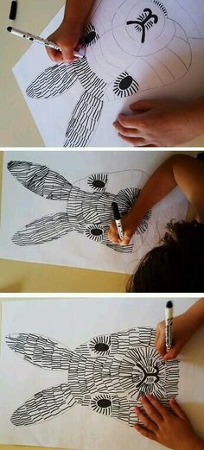
Thursday | Spelling  Synonyms and Antonyms  https://www.bbc.co.uk/bitesize/articles/z9r8r2p  Activities 1 and 2 | English  https://www.youtube.com/watch?v=TbQSdapmALw  Watch the video of Weslandia being read, pay close attention to the pictures. Today I would like you to create a place to which you would like to invite others. Draw our own landia! You can colour, paint or even collage you landia but make sure that it is detailed! | Maths  Pick one of the multiplication investigations to have a go at – remember to challenge yourself!  Mammoth Multiplication (mild) or LCM Squares investigation (spicy) | Allotment  https://www.exmouthallotments.co.uk/index.php/apply  Click on more info and find the two allotment sites in Exmouth: Hamilton Lane and Pound Lane. Look at the site maps then search for these allotments on Google Earth. Use the map to find out about the size of each allotment and the key geographical (rivers/seas/hills etc) and human features (buildings, shops, houses etc) nearby.
Friday | Science  Composting. Have a look in your garden if have one and see if you can spot anything decomposing.  Watch the video for help.  https://youtu.be/Q5s4n9r-JGU | Maths  Spend some time working on your times tables you can do this using TT Rockstars or Hit the Button.  https://www.topmarks.co.uk/maths-games/hit-the-button | ICT  Variables in Games – Lesson 1 Introducing Variables  https://classroom.thenational.academy/lessons/introducing-variables-71k68d | Spelling  Synonyms and Antonyms  https://www.bbc.co.uk/bitesize/articles/z9r8r2p  Activity 3
Reading
This week I would like you to read for 20 minutes every day. You can read your reading book, a book at home or you can access a book through
https://www.getepic.com/
If you have not already logged in the code is: Jla6766
Click on your character and explore the books in your AR band, have fun!

Please be aware that your home filter may allow unsuitable links to pop up when watching any YouTube videos.

Please remember to send in your work to the year 5 email address: Y5Teacher@littleham.devon.sch.uk

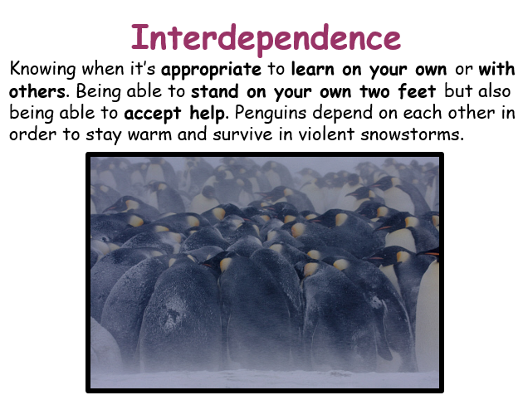
This week’s learning animal is the penguin. The penguin knows when it is appropriate to learn on its own or with others. They stand on their own two feet but know when to accept help! Look for times when you are learning like a penguin!

