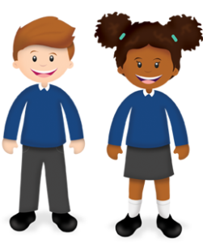
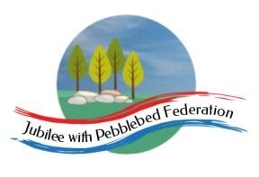
Learning from Home

Year: 3  Wk beg: 11.1.2021 | Lesson One  (Look at this week’s reading comprehension activity on google classroom) | Lesson Two | Lesson Three | Lesson Four
Monday | Reading  Read library book or allocated bug club books | English  Go to google classroom  Monday 11th January 2021  LO: I can find similarities and differences between a normal dictionary and 'The Dictionary of Difficult Words'. | Maths  Go to google classroom  Monday 11th January 2021  LO: I can add pairs of 2-digit numbers by partitioning. | Science  Go to google classroom  Monday 11th January 2021  LO: I can identify that humans and some other animals have skeletons and muscles for support, protection and movement.
Tuesday | Reading  Read library book or allocated bug club books | English  Go to google classroom  Tuesday 12th January 2021  LO: I can recognise a subordinating conjunction within a sentence. | Maths  Go to google classroom  Tuesday 12th January 2021  LO: I can add pairs of 2-digit numbers by partitioning. | RE  Go to google classroom  Tuesday 12th January 2021  How did the religion of Islam begin?
Wednesday | Reading  Read library book or allocated bug club books | English  Go to google classroom  Wednesday 13th January 2021  LO: I can explore complex sentences. | Maths  Go to google classroom  Wednesday 13th January 2021  LO: I can add pairs of 2-digit numbers by partitioning or counting on. | History  Go to google classroom  Wednesday 13th January 2021  LO: I can describe the achievements and influence of the ancient Greeks on the wider world.
Thursday | Reading  Read library book or allocated bug club books | English  Go to google classroom  Thursday 14th January 2021  LO: I can explore complex sentences further. | Maths  Go to google classroom  Thursday 14th January 2021  LO: I can add pairs of 2-digit numbers by partitioning or counting on. | Geography  Go to google classroom  Thursday 14th January 2021  LO: I can analyse maps, atlases and globes, including digital mapping, to locate countries and describe features studied.
Friday | Reading  Read library book or allocated bug club books | English  Go to google classroom  Friday 15th January 2021  LO: I can write complex sentences. | Maths  Go to google classroom  Friday 15th January 2021  Quiz | RE  Go to google classroom  Friday 15th January 2021  What are the five pillars of Islam?

