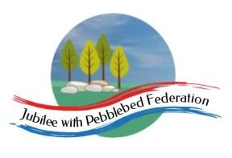

Year 5 Learning from Home Grid
Week Beginning 22.2.2021
Please remember to send in your work either in your paper pack, on Google Classroom or to Y5Teacher@littleham.devon.sch.uk we really enjoy seeing what you have been doing so please send it in!
Learning Behaviours
In school we are really thinking about:
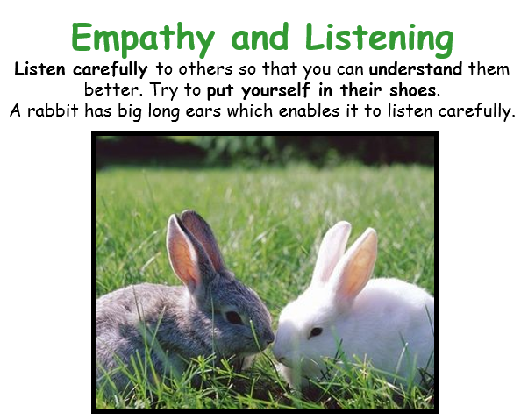
Reading – This week we are going to continue exploring the new website called Get Epic, please click on the link or copy and paste the link below into your web browser to get going!
https://www.getepic.com/book/50100547/a-writing-kind-of-day-poems-for-young-poets?utm_source=t2t&utm_medium=link&utm_campaign=content&share=31358209423

Once you reach the page with the cover of the book on, click on Class Code on the bar at the top and then enter this code:
Jla6766
Next click on your character, if you have already entered an email address this should allow you to access the book if you have not done this it will then ask you to get a grown up to enter their email address to allow you to continue. Once you have done this enjoy reading to the book.
Please ensure that you monitor any YouTube clips for ads and ensure that your children only click on the links to the videos that I have included.
Monday | Mental Health Day!  Today we are celebrating and looking after our mental health. During today we would like you to choose activities from the poster which can be found on the website http://www.littleham.devon.sch.uk/website,  in Google Classroom or in your paper pack to do. There are plenty of ideas to try! Please share your activities via Google Classroom, Y5Teacher@littleham.devon.sch.uk or keep it safe ready to return to school with your next paper pack.  Collective Worship:  Follow the link to Mrs Padbury’s Collective Worship on Google Classroom
Tuesday | Reading:  Mirror – Jeannie Baker  https://classroom.thenational.academy/lessons/to-introduce-the-text-and-author-6ww32e  English:  Read and enjoy the selection of poems! Then decide which you like the best and complete the likes, dislikes, puzzles and patterns grid.  Maths:  Find Add and subtract any pair of 2-digit numbers and use the same strategies to add and subtract multiples of 10. Then:  - Follow the PowerPoint on Google Classroom or in your pack  - Work through the activity, challenge yourself to complete the challenge!  History:  Read the information about Tudor Punishments – they were all very nasty, some were worse than others! I would like you to create a fact file of your own about Tudor Punishments ranking them from the worst to the not so bad (if there was one!). You can include illustrations and explanations of what they were, how they worked and who was punished and why. I can’t wait to read these so please if you can upload the work to Google Classroom or take a photo and send it to me at Y5Teacher@littleham.devon.sch.uk  PSHE:  Money Matters Lesson 3 Growing Money  https://classroom.thenational.academy/lessons/growing-money-6mu30r
Wednesday | Reading:  Mirror – Jeannie Baker  https://classroom.thenational.academy/lessons/to-infer-from-images-and-make-comparisons-70tp4d  English:  Read the 3 poems, then choose one of them to learn and remember. You could even add actions or percussive accompaniment (clapping or tapping!). Perform your poem to someone at home, then think about this question - ‘What sorts of poems are good to perform, and why?’  Collective Worship:  Exmouth Coastal Churches  https://www.youtube.com/watch?v=ibcdh2V0VtQ&list=PLqWt6-qhTKHF_Yb18Npn-Ni0kRTQ-9-yp  Look at the playlist on the side for the Collective Worship for this week  Maths:  Find Use counting up (Frog) to subtract 4-digit numbers from multiples of 1000.  - Follow the PowerPoint on Google Classroom or in your pack  - Choose your activity – Mild or Spicy (challenge yourself if you can!)  Music:  https://www.bbc.co.uk/teach/school-radio/history-tudors-music/zm4gvk7  Listen to the 8 pieces of Music – What do you think of them? What do you picture in your head when you hear them? Choose your favourite picture, listen to it carefully – what instruments can you hear? What can you picture in your head when you listen to it? Draw a picture of what you see in your head (remember we have used this method of showing our appreciation for music before when we worked on Ancient Egypt), remember to use colour and plenty of detail, you could even include the instruments that you can hear!  Mental Health:  Please follow the link to the school website and work through the PowerPoint/Activity you find there – this is also available on Google Classroom.  http://www.littleham.devon.sch.uk/website/mental_health/535426
Thursday | Reading:  Mirror – Jeannie Baker  https://classroom.thenational.academy/lessons/to-use-images-to-make-comparisons-and-predictions-75gp6c  English:  Acrostic Poems  https://www.bbc.co.uk/bitesize/topics/z4mmn39/articles/ztdvw6f  Watch the clips carefully. In an acrostic poem the first letter of each line spells a word when read downwards. However in a mesostic poem (which is another type of acrostic poem) the word is in a different place. Read A Sunny Day. Can you spot the word? Sunshine has been spelt downwards but this time each letter is in the middle of each line. By doing this it means that the poet can choose interesting vocabulary and imagery to paint a picture – this is a mesostic poem.  Choose a word from this list:  Snow  Rainbow  Dragon  Birthday  Thunder  Think about the word – what is it? How could you describe it? Write down your ideas and then try to write an acrostic poem or if you want to, challenge yourself a mesostic poem.  Here is my example of an acrostic poem:  Lighting up the pitch black night time sky  In jagged streaks  Going downwards rushing  Hitting the ground striking hard  Thunder rumbles around  Nothing moves outside  Inside people shelter like ants  Noticing the brilliant slashes in the night sky  Grateful to be safe indoors.  And a mesostic poem!  Running arounD wild and free  Digging in the Open ground  Ears flapping Grinning wide.  Please send your poems in either via Google Classroom, Y5@Littleham.devon.sch.uk or keep it safe in your paper pack to return to school when you collect your next pack.  Collective Worship:  ICE Exeter – see link on Google Classroom  Maths:  Find Decide what calculation is necessary to solve problems involving addition and subtraction/Choose strategies to solve additions and Subtractions  - Follow the PowerPoint on Google Classroom or in your pack  - Choose your activity – Mild or Spicy (challenge yourself if you can!)  - Complete the Problem Solving and Reasoning questions  Outdoor Learning:  Build your own board game – see the instruction sheet on Google Classroom or in your paper pack.  Y5Teacher@littleham.devon.sch.uk
Friday | Reading:  Mirror – Jeannie Baker  https://classroom.thenational.academy/lessons/to-use-images-to-make-comparisons-and-links-between-the-two-stories-6gu3et  English:  Work through the Riddle PowerPoint, then plan and write your own riddle. You can find the PowerPoint and the planning sheet on Google Classroom or in your paper pack. Please send your poems and plans in either via Google Classroom, Y5@Littleham.devon.sch.uk or keep it safe in your paper pack to return to school when you collect your next pack.  Maths:  Find Use decomposition to subtract pairs of 5-digit numbers.  - Follow the PowerPoint on Google Classroom or in your pack  - Choose your activity – Mild or Spicy (challenge yourself if you can!)  ICT:  What makes a good website?  https://classroom.thenational.academy/lessons/what-makes-a-good-website-c9gkcc  RE:  Our focus for this half term is Judaism. Work through the following website: https://www.bbc.co.uk/bitesize/topics/znwhfg8/articles/zh77vk7  Now fill in the What I already know and What I would like to find out columns on the grid, leave the What I have learnt column as we will fill this in at the end of the unit.

