Translation of shapes. Translation is moving in a straight line.

The blue shape at the top is translated 3 squares to the right (x axis) and 2 squares down (y axis). Look at where it is now. Note that each corner moves to the right 3 squares and down 2 squares.
Use the grid on the next sheet to translate each shape.
- The square is translated 4 squares to the left and 2 squares up.
- The rectangle is translated 2 squares to the right and 4 squares up.
- The triangle is translated 3 squares to the left and 1 squares down.

We can use coordinates with translation. Remember, when you read coordinates, you read ‘along the corridor and then up the stairs’. In other words the x coordinate (left to right) comes first and the y coordinate (up and down) comes next.
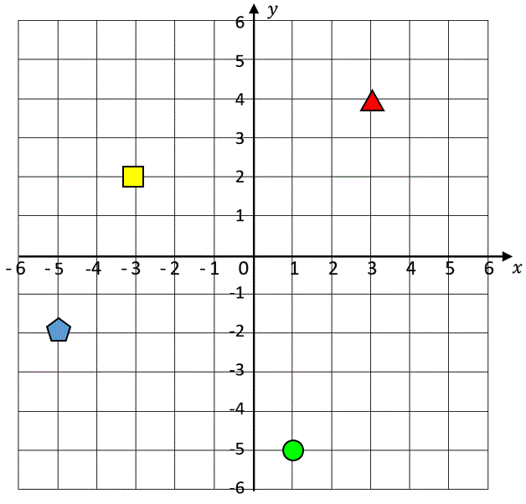
The coordinate of the yellow square is -3, 2 because it has gone across the x axis to -3 and up the y axis the 2.
Write the coordinates for:
- The triangle ……………………….
- The circle ………………………….
- The pentagon …………………..
Answers
- Triangle 3, 4
- Circle 1,-5
- Pentagon -5,-2

Translation and coordinates.
If I translate a point 4 squares on the x axis, if moves 4 places to the right in a positive direction.
If I translate a point -4 on the x axis, it moves 4 places to the left in a negative direction.

If I translate a point 3 squares on the y axis, if moves 3 places up in a positive direction.
If I translate a point -3 on the y axis, it moves down 3 places down in a negative direction.

If I translate the triangle -2, 1, this means it moves to the left on the x axis 2 squares and moves up the y axis 1 square.
Its new coordinates are 1, 5
Try these:
- Translate the square 2,3. (It goes to the right 2 squares and up 3 squares)
- Translate the circle -4, 2 (4 to the left and 2 up)
- Translate the pentagon 7, -2 (7 to the right and 2 down)
- Draw a shape at point 3,-1. Now translate it 2, -3. Draw where it should be.
Answers
- Square is at -1,5
- Circle is at -3, -3
- Pentagon is at 2, -4
- Your shape is at 5,-4

