YEAR 6 The Ickabog by J K Rowling.

We listened to J K Rowling reading the chapter that describes the Ickabog and took notes from the reading. We began to investigate sketching eyes and mouths using different HB pencils to give shade and tone.

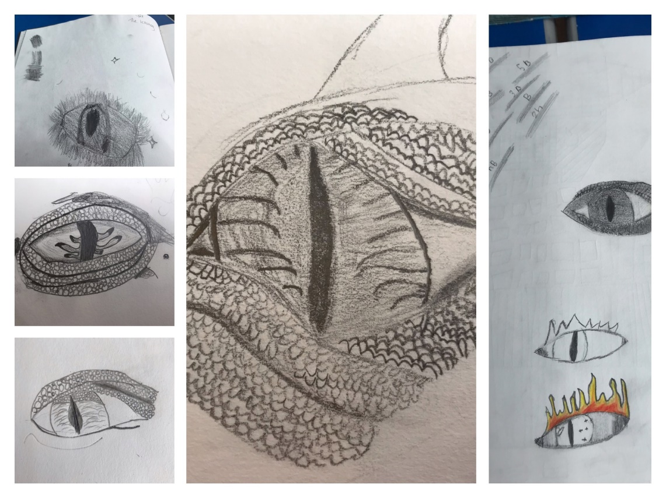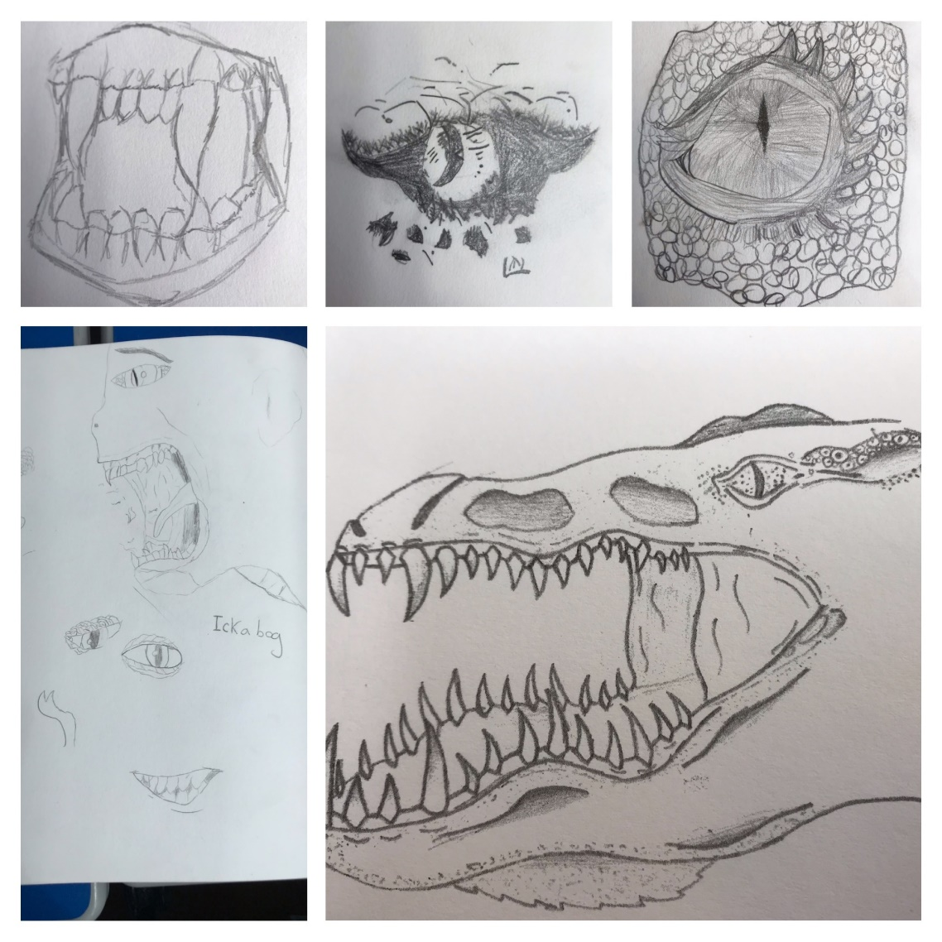

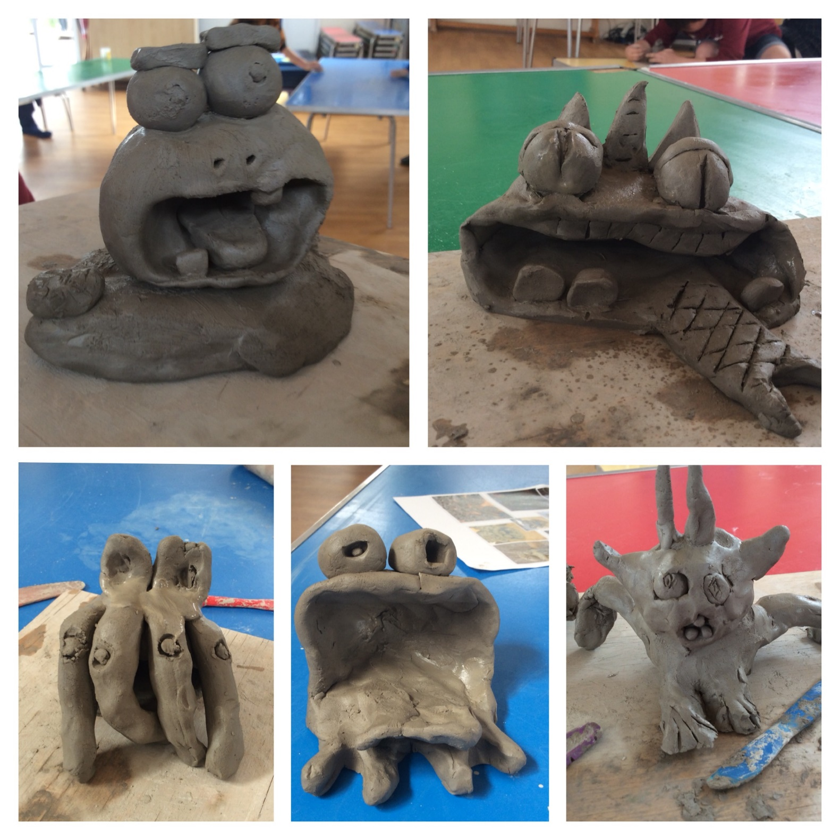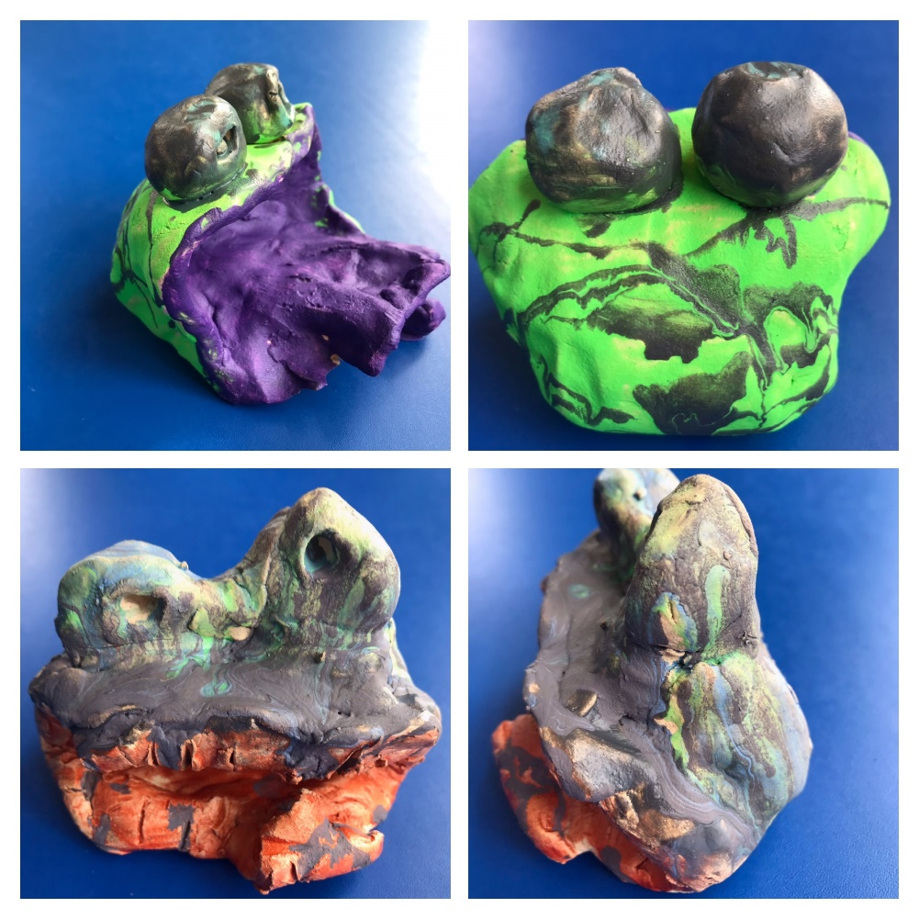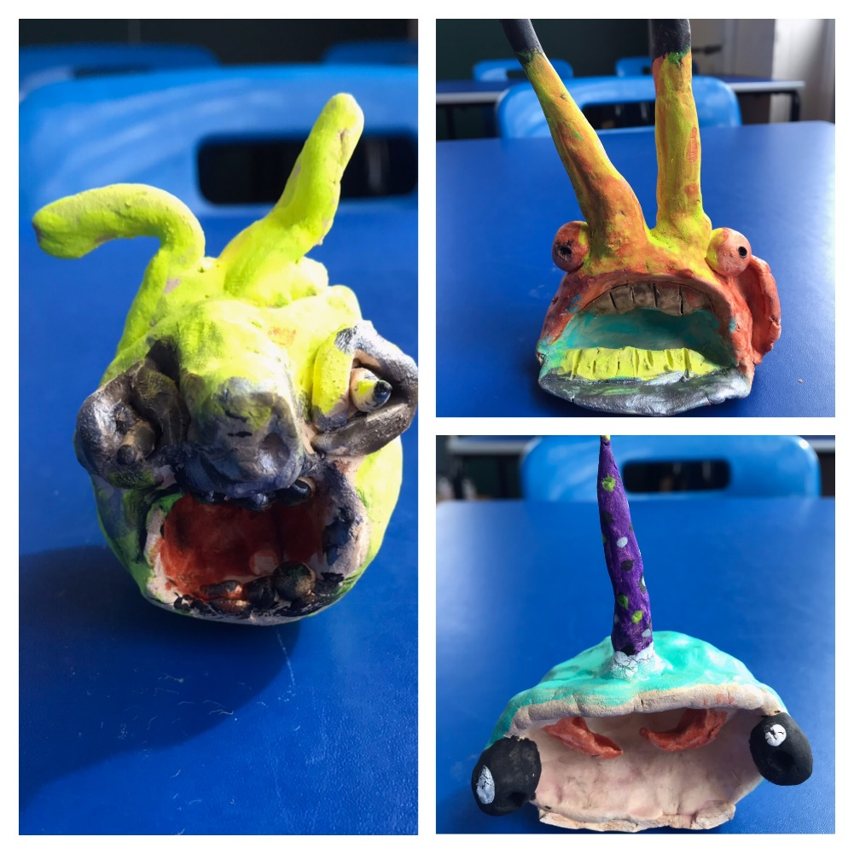

We planned and created our own clay sculptures from our imagination and ideas of what an Ickabog may look like. We learned how to attach other pieces of clay to our models and used a range of tools to add texture and features.

Finally, we used poster paints with PVA glue to add colour to our models, we investigated colour matching and the different effects that the paint could give us as well.