Hub Weekly Challenges 5
Week beginning 18 May 2020
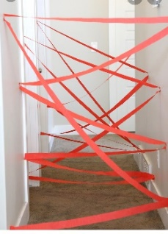  Get Building Challenge  Can you build a paper maze? Can you get through it without breaking any of the paper? | Arty Crafty Challenge  Can you make hand or footprint animals?  How many animals can you make?  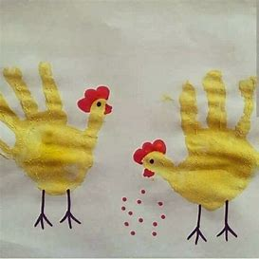  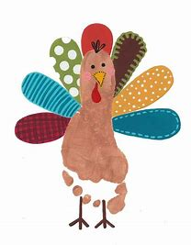  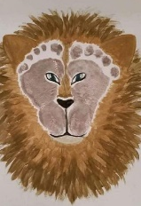
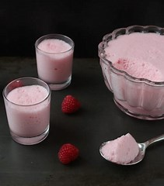  The Tasty Challenge  Have a go at making Jelly Fluff -this is what Mrs Cambridge used to make when she was growing up!  https://www.butcherbakerblog.com/2010/03/01/jelly-fluff/  Basically, make the raspberry jelly with half the recommended water. Whisk a tin of evaporated milk until it triples in size. Whilst whisking, slowly add the jelly. Put in the fridge to set and enjoy! | Keep Fit Challenge  Can you make an indoor or outdoor obstacle course? Ask someone to time you how long it takes for you to complete it. Remember to be safe!
Can you find out Challenge?  Freddie found out that the Burj Khalifa in Dubai was currently the tallest building in the World at 829.8 metres and the Sears tower in Chicago was tallest at 442 metres in 1984! Good research skills Freddie!  He would know like to know what is your favourite song and why? | Pass the Parcel Challenge  Continue with your stories, poems and newspaper articles. You have a new one that has been passed onto you this week. You need to write the next paragraph or verse ONLY and then email it back to me. Each week, I’ll pass the stories around….amongst the adults as well! Our writing will grow each week.
Grill a Teacher Challenge  This week’s teacher is Mrs Grey our Executive Headteacher. She has a Blue Peter badge, you might like to ask her about it!  Email any questions you would like to ask her. | Your turn!  Would you like to set any of the challenges next week? Email me any of your ideas. Maybe you would like to set a Tasty Challenge or the next Keep Fit Challenge. Be creative!  Thank you Freddie for setting us a new challenge again. Keep them coming!
I will email this out to you on a Monday. Please send me an email once a week with any of your responses, pictures etc. By Sunday 2.00pm please if you want your entries to be included. Send me an email to keepintouch@littleham.devon.sch.uk

Pass the Parcel Writing!
Mrs Jones:
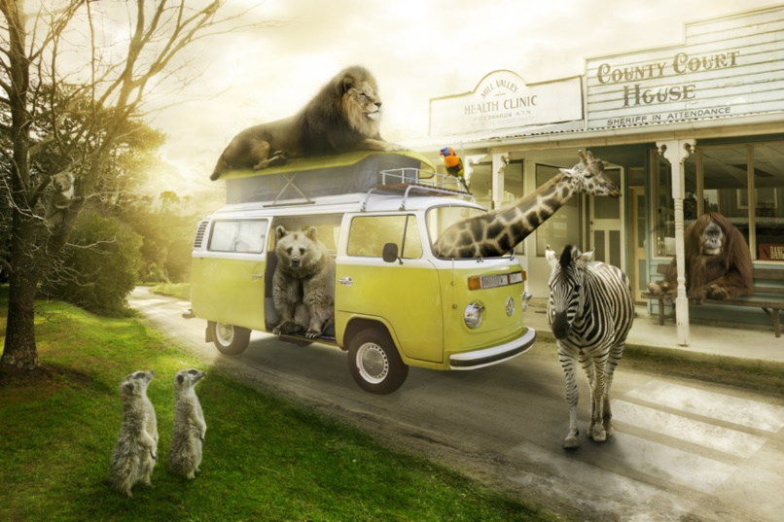
Most visitors are a little shocked (to put it mildly) when they arrive at Animal Town. Despite the fact that the name of the town gives a slight indication to passers-by that the inhabitants of the town are ‘not normal’, it’s as if people don’t believe things until they see them with their own eyes!
Once you get used to being in Animal Town – or so they say – seeing an orangutan behind a desk in a sheriff’s office and upholding the law to an impeccably high standard becomes relatively ‘normal’…
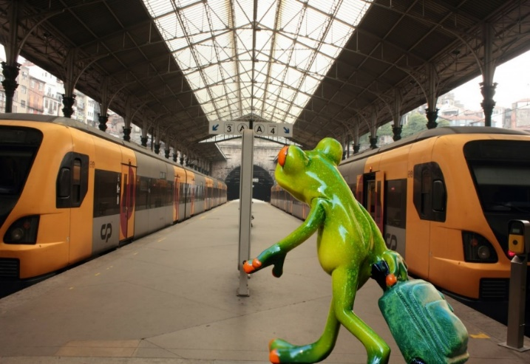
AF: There is even a train station that is run by a Rattlesnake called Lucy and her family. They help the other snakes to and from London, Zootropolis and Penzance.
GC: It is not unusual to see Zebras, in their black and white uniform of course, patrolling the streets, enforcing strict car parking measures, giving out the occasional parking ticket and obviously monitoring Zebra crossings! Don’t be fooled, these animals may look harmless and have on occasion, even been called cute, but they are feisty! There is literally nothing you can do to explain away why you had to park on the double black lines or why you decided to cross the Zebra crossing backwards. Fines and tickets are issued daily.
FMH: The local restaurant has a chef that is an Octopus as he will be able to cook a lot of things at once. The meals are served by monkeys as they can balance things well.
The school headmistress is a Mrs Whales (a small whale ) she doesn’t say a lot and stays in her office. There is a teacher called Miss Fishy, a very quiet fish, that is not too clever and forgets what she has said very quickly.
SH – The thing is, this Animal town appears relatively ‘normal’ of a day (once you get used to it of course!) Orangutangs behind desks, zebras handing out parking tickets, snakes running train stations, tigers riding bikes, cats being the best hair dressers in town and even the elephants have got their nail salon set to up to perfection. So good, their awarded best in town each year! The list really does go on, but what the visitors of Animal Town do not know, is that things drastically change of a night time. I mean, did they not tell you the Animals become humans when the sky is dark?!
At night the animals turn to humans so they can sleep in comfy beds.

Freddie:
There was an old man with a beard
Who said, “It’s just how I feared!
Two owls and a hen
Four larks and a wren
Have all built their nests in my beard

JC -There was a silly old cat,
He wore a coat, some gloves and a hat,
He ate all day long,
To be big and strong,
But ended up very fat!

A young witch called Nellie,
Made potions that were smellie,
The spells were not right,
As she was not bright,
And she ended up with a sore belly!

GC- There was an old teacher indoors,
Who had no children just chores,
She wanted to teach,
Get away from the bleach,
But she just kept cleaning the floors!

SH - ​There was an old hedgehog who was very slow,
But in the garden, beautiful flowers are starting to grow,
The hedgehog often sunbathed, he liked the suns glow,
The grass is so long it’s definitely ready to mow!
Must remember the vegetable seeds are set to sow,
If you see a dandelion, don’t forget to make a wish and blow!

Miss Hitchcock
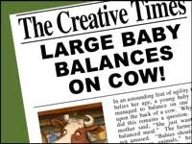
Yesterday, locals in the village of Hamlittle were shocked to see a giant baby sitting on a cow in a field that belonged to Farmer Jack McDonald (postcode , ei ei o).
Concerned for the baby's wellbeing, a local girl-Miss Muffett called the authorities and contacted us at the Fabled Times. Constable Dick Wittington was quick to attend the scene and deal with the situation. On speaking to Farmer Jack he was able to establish that there was no cause for concern as Jack informed him that the Beanstalk had grown back and that the baby belonged to the Giant family who lived in a castle in the clouds and they often came down to visit Jack and meet the cow that had brought the two families together. Mrs Giant was very positive about the friendship and said, " Although we are from different backgrounds, we get on famously.” Reporter: Jacqui Clark

Alex reports that the giant was killed when the beanstalk was chopped down were false and he also does not like to grind people’s bones to make his bread. It appears that Jack made up these stories so he would not get told off for stealing the magic harp and the hen by his mum.

GC -Witnesses in the village of Hamlittle report that Miss Muffett felt so guilty for having got the police involved, so took Farmer Jack a sack of seeds, some curds and whey and a bottle of his favourite cider to say sorry. Jack apparently was taken aback by this surprising show of kindness and was seen to blush rather red…..Miss Muffett is considered to be rather beautiful!! Eyewitnesses say that while, Miss Muffett was sitting on a bale of hay admiring Jack’s recently planted fields, a rather large spider caused Mabel Muffett to scream. Farmer Jack, leapt to her rescue rather heroically and is now seen as the local hero. Mabel has been seen since often taking her daily walk in Jack’s fields!

Mrs Cambridge:
I wish there was a law that said………

KJ: That adults aren't in charge of children 7 days a week.
For one day, children have free reign. They can choose what they want to do, and where they want to go, and the adult must adhere to the rules!

JC: That when it’s your birthday you can have a day of school/work and everything is paid for. You could take a day trip anywhere. Eat what you want and everyone you meet greets you with a smile and sings ‘Happy Birthday’!

Freddie and Forest school friends:
- All public transport over the whole country to be free for people over 70.

- Litter dropping especially plastic is to be fined. 1st time £ 110. 2nd time £ 310. 3rd time £ 1000. 4th time -1 month in prison

- Eating egg sandwiches in confined spaces to be banned.

- All students up to age 18 should have free public transport during term time.

AF: I wish School were optional and if you did have to go discos are a must every day.
I also wish you could eat all the sweets you want without the consequences.

Alex:
In six days there will be no more chocolate in the world….ever! That’s what it said on The Seven Show. Jelly had nearly reached the next level of Zombie Puppy Dash, but hearing this made her plunge the pink puppy into a huge tank of zombie dog food. “Woah! What was that about chocolate….”
KJ: Jelly could not believe what she was hearing! How can this be?! Chocolate is Jelly's most favourite thing in the world (closely followed by Zombie Puppy Dash)
Jelly dreamed that one day she would own a chocolate shop, filled with all of her favourite bars; Crunchie, Twirl, Lion, Milkybar, Mars bar, to name a few. A chocolate bar Buckingham Palace to attract the customers, but now Jelly will have to think of a new dream...........
Jelly had to start the level of Zombie Puppy Dash again, and Jelly better eat chocolate for breakfast, lunch, and dinner for the next six days.
JC: Jelly began her new plan the next day. Chocolate was the priority though and she was going to make a big start right now for breakfast: Chocolate pancakes with chocolate spread, chocolate dip ( for a few strawberries) and a large chocolate milkshake , “yummy yummy “.
After such a delicious start to the day Jelly did wonder if she had eaten too much chocolate and would there be enough for the next 6 days?
What was she going to do? No more chocolate FOR EVER!!
Could she make some? No
Could she grow some? No
Was there anything that she could have instead that tasted as fantastic as chocolate? Probably not.
She sat down in a gloomy mood and decided to play her game to cheer herself up. The Pink Puppy was so clever making it through the tricky Zombieland zones getting a special treat when a level was completed.
Then the idea came to her-" I’ve got it , I know what I’m going to do “......

Mrs Clark – you can add to either of the diaries below
Dear Diary,
Today, the doorbell rang, and I eagerly ran down the stairs. By the time I had opened the door, the delivery driver had vanished, but a giant box had been left on my doorstep.
​SH - The box was too heavy to lift and too big to get through the door. I opened it to find a smaller box inside, covered in chains and padlocks. A note was stuck on the top that said ‘this box of secrets has been hidden for hundreds of years. Look closely and follow the clues’
I sat next to the box for a while, reading the note, wondering how I was going to solve this mystery. A white feather with two black spots on fell from the sky and landed on my foot. I picked it up and looked at it closely. Was this my first clue?
HT – The feather had a note attached to it. It said, “The next clue is somewhere you can find a feather.”
So we went to a chicken coop to see if we could find it. To my astonishment, the clue was glued onto the chicken. Before I could read it, I had to catch it. The chicken flapped everywhere dropping feathers all over the place until I spotted a bag of seeds. I put the seeds into a box and the chicken fell for my trap. I caught it with a net. The note said,
“You will find it where every animal goes to drink. It’s not the river”
So we went to the watering hole and I was amazed. The loch ness monster had the note taped to his back. I took all my clothes off and went for a swim. I grabbed hold of his tail and he shook me like a rag doll but I managed to climb onto his back and have a ride. I got the note and rode back to shore and ran away as fast as I could.

OR
KJ - Dear Diary,
Today, the doorbell rang, and I eagerly ran down the stairs. By the time I had opened the door, the delivery driver had vanished, but a giant box had been left on my doorstep.
What had I ordered during this lockdown period??
I opened the box and inside that a smaller box - wrapped in yellow and pink polka dot paper, but it was empty.....
I opened that box, to find an even smaller box - wrapped in green and blue polka dot paper, again the box was empty.....
I was wondering why all these boxes were empty, but as I looked again I saw a small package. I opened it to find a small frame which read "True friends are never apart, maybe in distance but never in heart"
This made me smile...........
Harry – you can add to either of the stories below
Bleary-eyed, I went downstairs for breakfast, the house was empty, even the furniture had gone.
GC -I rubbed my eyes. Am I dreaming? But as my eyes adjusted to the morning light creeping in through the slits in the curtains, I realised this was no dream. What was happening? Walking around, in a shocked daze, I noticed dents in the carpet where the furniture had been. There had sat my favourite rocking chair with my fluffy purple cushion; over there had lived my piano with one key missing and beyond had stood my slightly faded sofa. Suddenly, a chill ran down my spine, and turning sharply, I thought I noticed a slight scurry of movement in the corner of the room.
SH: As I turned, the piano key flew across the room and the piano started to play. What on earth was going on? I rubbed my eyes again, I couldn’t quite believe what I was seeing. I crept across the squeaky floorboards towards the piano key that was dangling in front of the living room window. As I reached out to get it, it flew straight past me and up the stairs. Now I really was nervous, but I slowly crawled up the stairs, following the piano key. It led me to the bathroom, but my bathroom was no more, there in front of me, was a spiralling circle, whizzing around so fast I went a bit dizzy! I sat on the floor, the piano suddenly stopped and a whispering voice said ‘Crawl through the whizzing tunnel, your adventure is about to begin’.
OR

Bleary-eyed, I went downstairs for breakfast, the house was empty, even the furniture had gone
KJ: I quickly went to look around the house to see if I could find any clues as to what had happened? Where had everything gone? I went into the kitchen and a cupboard door was open, so I peered inside. Sat on the shelf, was an old wooden box. I took it out slowly, it was quite heavy. The top of the box read 'Carnival Of Colour Open To Play'
I took the box into the empty living room to open it. It was a board game. Inside were two dice, two rainbow coloured counters, and a start to finish shaped like a snake.
Nervously I picked up the dice and rolled them onto the box.... 7. I moved one of the rainbow coloured counters 7 spaces.....then there was a huge puff of red, yellow, green, blue, orange smoke that filled the whole room. I couldn't see anything. As the coloured smoke settled I looked around, I wasn't in my living room anymore. I was in a forest surrounded by the most colourful trees and the board game next to me, which now read 'roll to play again'.........

Hub Exhibition

w/b. 20.4.20 Alex’s bottle rocket, carrot cake and proudly wearing his new Blue Peter badge which arrived this week. FANTASTIC!
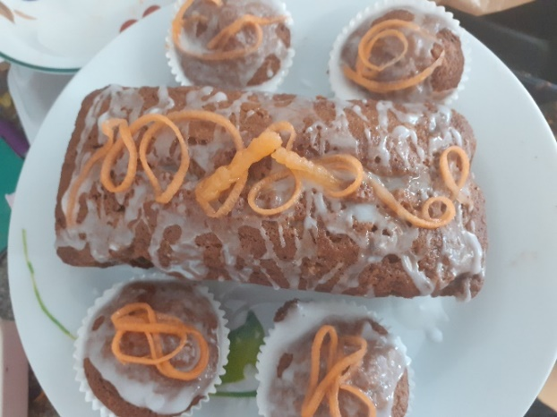
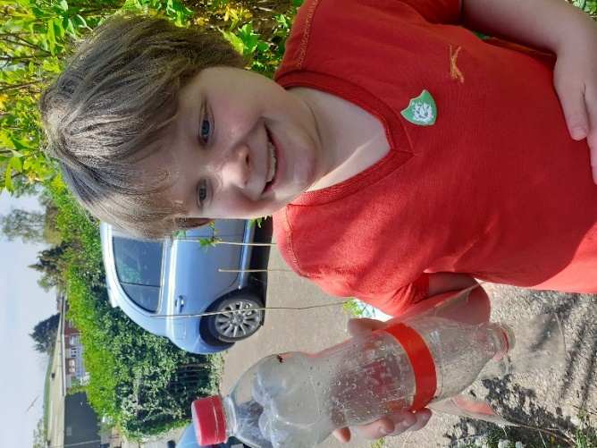
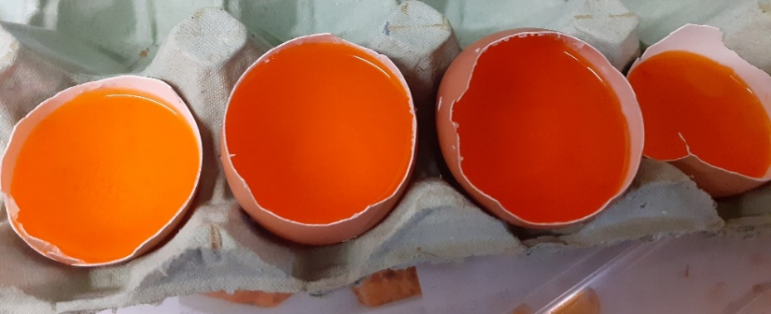
w/b. 27.5.20
Alex started to make his crystal geode eggs.
These look exciting! Can we have a picture once they have crystalised?

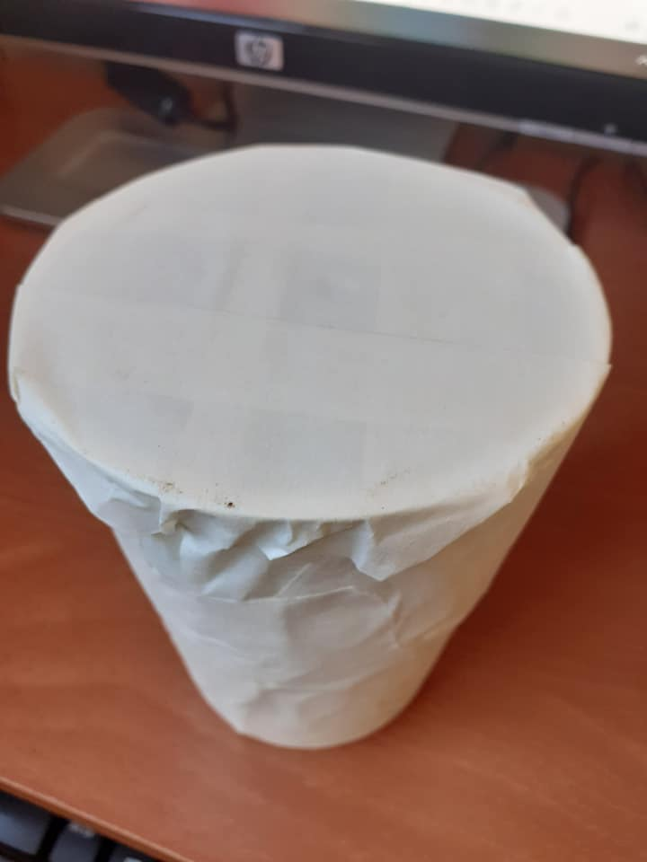
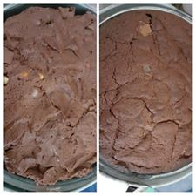
w/b 4.5.20 Alex’s chocolate concrete -before and after baking

Yoghurt pot drum
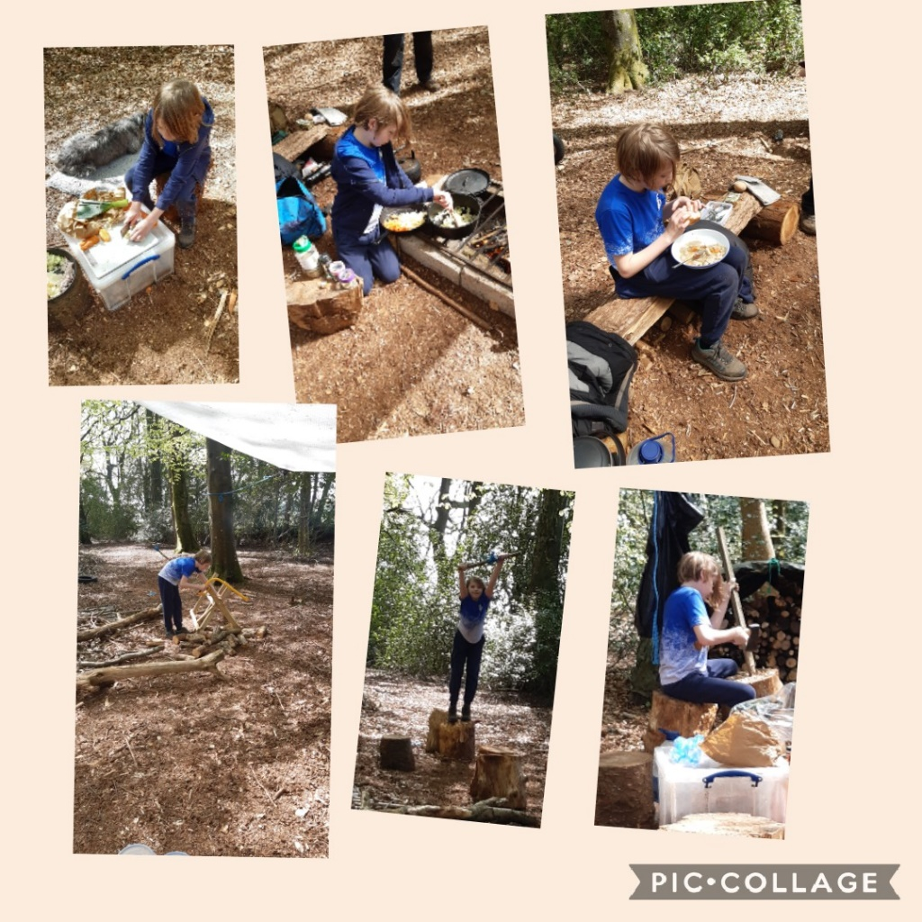
Fun at Forest school! That food looks delicious Freddie!

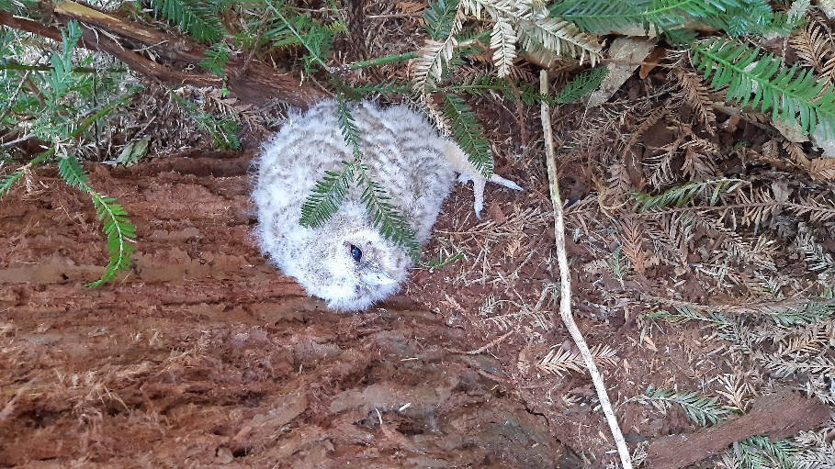
Beautiful baby tawny owl seen at Forest school -I bet you wanted to take it home with you Freddie!

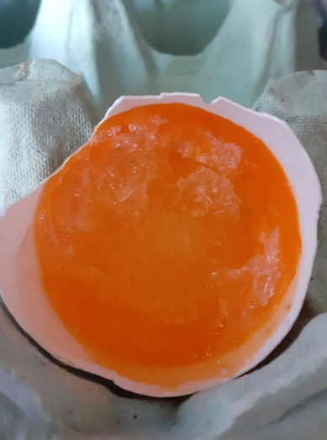
Alex Goode egg update…beginning to crystallize.

w/b. 11.5.20 Alex’s Lemon volcano
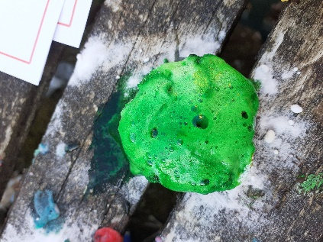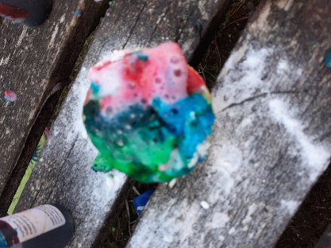
We tried lime and orange
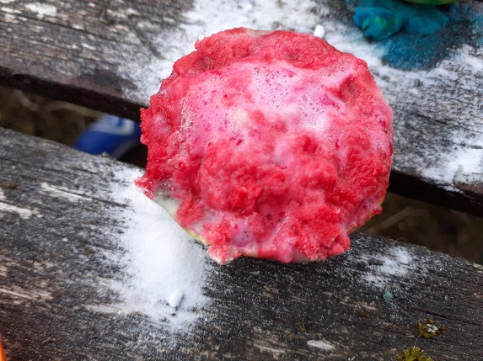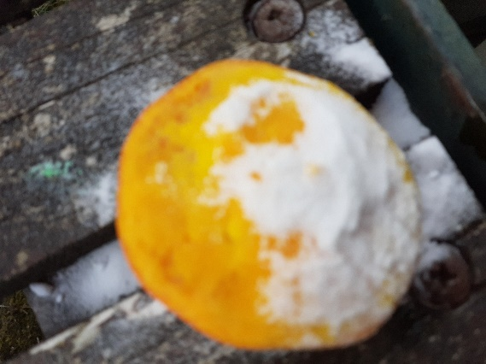
Out of the three Lemons worked the best
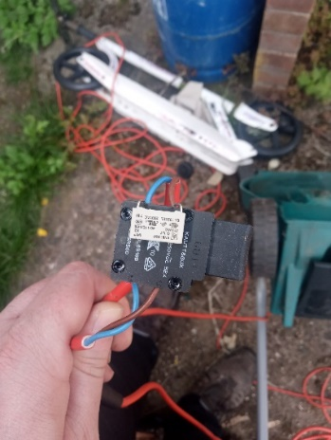
Mrs Gibson dropped an old lawn mower off for Alex to take apart he needs to tell her 6 things about it. This looks exciting Alex….I look forward to hearing all about it!

