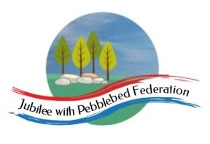

Year 2 Learning from Home Grid
Week Beginning 25.01.21
If you are going to the supermarket there is an activity that involves marsh mallows and spaghetti later in the week . Perhaps you could add these to your list if possible.
Think about how we can develop your child’s learning behaviours. This week we are looking at questioning, being curious like a cat.  Tell Mrs Hooper how your child has shown this behaviour this week either by email or returning the slip. | 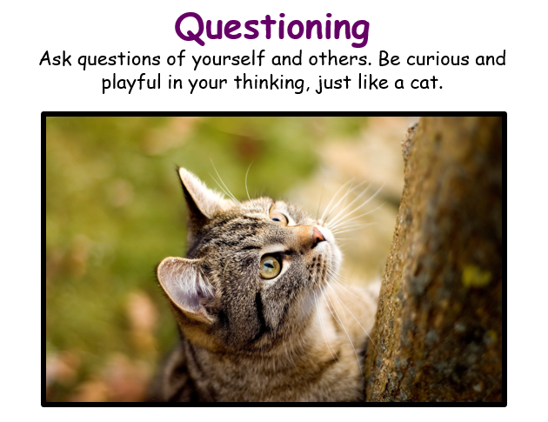
Monday | Reading (30 Mins)  Read the book you have been sent in your home learning pack, these are the sounds you are working on. There is also a book specific to you on Bug Club as well as phonic games you can play.  Phonics (30 Mins)  Sound ow as in sparrow. Watch the video and do the activity.  https://youtu.be/KCnwj95o4wM  Worksheet 1 from the pack you have been given or online in bug club, If you can’t type on the sheet online you can write the answers in a list and send it to me by email at Y2Teacher@littleham.devon.sch.uk  English (30 Mins)  Lets go to the movies !  We are going to learn all about traditional stories and in the end you will be writing one of your own. But for today let’s think about what they are and enjoy some. Write a list of all the traditional stories you can think of. If you are on Google you can type the list and email it to me. If you are working on paper write your list on the next clean page of your book and take a photo and send it in by email to Y2Teacher@littleham.devon.sch.uk . I look forward to seeing all the tales you think of !  Maths (30 Mins)  Start by practising pairs of numbers that make 6 for five minutes.  Please watch and talk through slides 8-22 on the power point then solve the questions on the sheet in your pack. If you are learning on line you need to choose which sheet to respond to from the sheet 1,2 or 3 from day one (days are noted on the bottom right hand corner) Please take a photo of your work and email it to me at Y2Teacher@littleham.devon.sch.uk, so I can mark it. You can send the real thing in next week when you return your paper pack.  RE (30 Mins)  Watch the video link below and then complete the activity from Mrs Shepherd.  www.bbc.co.uk/teach/class-clips-video/religious-studies-ks1-the-five-pillars-ofislam/zv84jh  PE (30 Mins) With Joe Wickes  https://youtu.be/sX05HHni9Wk
Tuesday | Reading (30 Mins)  Read the book you have been sent in your home learning pack, these are the sounds you are working on. There is also a book specific to you on Bug Club as well as phonic games you can play.  Phonics (30 Mins)  Sound o-e as in rope.  Worksheet 2 from the pack you have been given or online.  English (30 Mins)  Having thought about traditional tales are today you need to go to the movies. Have you got a dvd at home of say Cinderella or snow white you could watch? If you don’t have a dvd perhaps you could find one on Netflix or Sky if you have them. If you prefer, you could read a story together. If you have no access to these let Mrs Hooper know she will find a way of getting something to you. Please email in to Y2Teacher@littleham.devon.sch.uk to let her know what you are reading or watching we can work out which story is the most popular in maths.  Maths (30 Mins)  Please watch and talk through the slides 23-36 then complete the allocated work sheet I have sent to you in your home pack. If you are learning online please choose from sheet one two or three , day two. The days are written in the bottom right hand corner. Please take a photo and email it back to me at year2teacher@littleham.devon.sch.uk I would also like you to send me the paper sheet when you pick up your next pack next week.  Science (30 Mins)  https://classroom.thenational.academy/lessons/why-is-exercise-so-important-70w38d  Music (30 Mins)  https://classroom.thenational.academy/lessons/rhythm-symbols-and-patterns-6mw68t
Wednesday | Reading (30 Mins)  Read the book you have been sent in your home learning pack, these are the sounds you are working on. There is also a book specific to you on Bug Club as well as phonic games you can play.  Phonics (30 Mins)  Sound o as in cold and oe as in toe. Watch the video and then do the activity.  https://youtu.be/yKMkkCbdOR4  Worksheet 3 from the pack you have been given or online.  English (30 Mins)  Two tasks to do today:  On the next clean page in your book first can you write a list of all the main characters in your story .  Now, on the next clean page you can turn your book sideways if you want to, ask a grown up to split the page into three sections labelled beginning, middle and end.  We know stories have a beginning a middle and an end. Can you write and draw what happens at each part of the story. Handy hint: there is always some sort of problem on the middle that gets solved just in time for a happy ending. Please take a photo of your work and email it to Y2Teacher@littleham.devon.sch.uk  Maths (30 Mins)  Practice pairs of numbers that make 10 with your grown up.  Watch slides 37-47 on google classroom or the PDF file on your phone.  Complete sheet Day three 1,2, or 3 you choose if on line, I have sent you the appropriate challenge if working on paper. Please take a photo of your maths and send it to me or turn in online.  DTEC (45 Mins)  IN school we would be building a bridge this week with spaghetti and marsh mallows ! If you were able to get these at the shops this week that would be great. If you cant how else could you make a bridge at home ? I would love to see your photos I cant wait to have them emailed in !  Collective Worship (15 Mins)  Please log into you Google classrooms account to view the Collective Worship from Mrs Padbury.
Thursday | Reading (30 Mins)  Read the book you have been sent in your home learning pack, these are the sounds you are working on. There is also a book specific to you on Bug Club as well as phonic games you can play.  Phonics (30 Mins)  Language using the sound ‘o’ in reading and writing.  https://youtu.be/Z5u1kNa3kAY  Worksheet 4 in the pack you have been given.  English (30 Mins)  Noun or Adjective ?  We need to know which words are nouns naming words and which words are adjectives describing words. Using the words on the sheet in your pack or on Google classroom decide if each word is a noun or an adjective and copy it into the correct list.  Maths (30 Mins)  Please watch and talk through the slides 58-65 from the PDF either on your phone or google, then complete the allocated work sheet I have sent to you in your home pack. If on google you got it ! Choose from day four sheet 1,2, or 3 Print off and complete and take a photo to email or turn in on line if you can  Geography (30 Mins)  Take a walk to the Littleham Bridge on your daily exercise.  What is the bridge made from ?  What is it used for ?  What shapes is it ?  Do you know any famous bridges you could draw and label.  I would love to receive a photo of your daily exercise walk to the bridge if you are well and safe to do so.  PSHE ( 30 Mins)  Understand the need and reason for saving money.  Talk to your grown up why it is good to save money, think about what you would like to save for , small or large.  Complete the 1decision activity either uploaded to Google or in your pack.
Friday | Reading (30 Mins)  Read the book you have been sent in your home learning pack, these are the sounds you are working on. There is also a book specific to you on Bug Club as well as phonic games you can play.  Phonics (30 Mins)  Enjoy the assessment game assigned to you in Bug Club using the log on code you have been given.  English (30 Mins)  Read and talk through the uploaded Traditional tales quiz with a grown up. Then in your book or on paper can you write five quiz questions to ask me or you friends. I can post them from your friend next week if you send a photo by email. Please remember that questions have capital letters as well as a full stop.  Maths (30 Mins)  Mental maths :Practising quick recall doubles of numbers upto 10. Can you tell your grown up double of any number they ask you up to 10 ?  Please watch and talk through the slides 66-73.  Online learners day five sheet 1,2 or 3. Then complete the allocated work sheet I have sent to you in your home pack. Please take a photo and email it back to me at Y2Teacher@littleham.devon.sch.uk I would also like you to send me the paper sheet when you pick up your next pack next week.  Computing (30 Mins)  Using any drawing program or app you have, can you draw an image on your device of a castle ? Please save it because we will be working on it again next week adding bits . Have fun. I look forward to you emailing them to me on Y2Teacher@littleham.devon.sch.uk

