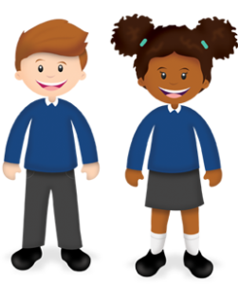
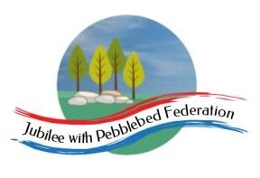
Learning
from Home

Year: 5  Wk beg: 30.11.2020 | Lesson One | Lesson Two | Lesson Three | Lesson Four
Monday | SPAG  https://classroom.thenational.academy/lessons/to-explore-simple-and-compound-sentences-6hk3ed  practise some of your own sentences  EXTRA-CREATE COMPOUND SENTENCES LINKED TO EITHER OUR SCIENCE, OR ANCIENT EGYPTIAN TOPIC | MATHS  https://classroom.thenational.academy/lessons/rounding-2-and-3-digit-numbers-to-the-nearest-10-6gu3er  Create problems to solve.  Practice your next times table. Remember the sort of games in class we do. | SCIENCE  www.bbc.co.uk/bitesize/clips/zsjd7ty  Watch the clip and try out some of the suggestions. What is going on? Be prepared to talk about what you have found out in class. | PE  Create your own workout programme, which you can present to the class, as a warm up session. E.g. Different pathways, star jumps, an imaginative 1 minute aerobic exercise. A stopping and starting routine. Be creative! There is always Joe Wicks to follow.  .
Tuesday | SPELLING  https://classroom.thenational.academy/lessons/to-explore-the-function-of-apostrophes-ctk38r | ENGLISH  Listen to the poem Bethlehem, at least twice. https://www.youtube.com/watch?v=DYPl3oO67wk  What did like? What did you dislike? Could you hear any patterns? Do you have any questions? Write all of these down. | MATHS  https://classroom.thenational.academy/lessons/adding-and-subtracting-using-partitioning-61h3cd | FRENCH  Number revision. Try counting out loud too!
Wednesday | SPELLING  https://classroom.thenational.academy/lessons/to-revise-using-apostrophes-68vk0c | ENGLISH  Listen to the poem Bethlehem.  https://www.youtube.com/watch?v=DYPl3oO67wk  Imagine you were there, what would you see, hear, smell, feel? Write a letter home to tell them about the events. | MATHS  https://classroom.thenational.academy/lessons/adding-using-the-column-method-6wt64c | HISTORY  https://www.kidsgen.com/ancient_egypt/book_of_the_dead.htm  Read about the Book of the Dead. Write your own transformation spell, which would transform a person in to a plant or animal and give them special powers and abilities in the afterlife.
Thursday | READING  Think about your favourite character from a book. Think of 5 questions you would like to ask them. Then write the answers as if you were that character. | ENGLISH  Adverbs and adverbials PowerPoint | MATHS  https://classroom.thenational.academy/lessons/subtracting-using-the-column-method-6xj32d | DT  Build your own pyramid like the Ancient Egyptians. You could build it out of Lego, boxes etc.
Friday | READING  Think about your favourite character. Write about what that character might be thinking or feeling at different stages of the story. You could write this in first person or draw pictures with speech bubbles. | ENGLISH  https://classroom.thenational.academy/lessons/to-write-prepositional-phrases-6th38e | MATHS  https://classroom.thenational.academy/lessons/problem-solving-using-the-column-method-c8up6c | RE  https://classroom.thenational.academy/lessons/what-is-the-holy-book-of-islam-cmvk0d

