VE Day – 2020
This year marks the 75 anniversary of VE Day. This is ‘Victory in Europe’ Day when World War II in Europe ended. If we had been at school, we would have had a party, similar to the one we did for the 100th anniversary of the end of WWI in 2018. You might have heard of Captain Tom Moore, the veteran of WWII who has raised money for the NHS Charities.
If you can, do a bit of research about VE Day.
You might want to find out more about aspects of WWII: Allies and Axis forces, famous battles, The Battle of Britain, D-Day, Dunkirk, the occupation or The Channel Islands or evacuation of children from the cities.
You also might want to find out about VJ Day.
If you can’t do any research, read on.

May 8th 1945 was the date the Allies celebrated the defeat of Nazi Germany and the end of Adolf Hitler’s Reich, formally recognising the end of the Second World War in Europe. This became known as VE (Victory in Europe) Day.
The Allies had begun to overrun Germany from the west during April as Russian forces advanced from the east. On 25th April 1945, Allied and Soviet forces met at the Elbe River, the German Army was all but destroyed.
After six years and millions of lives lost, the Nazi scourge was crushed and the war in Europe was finally over.
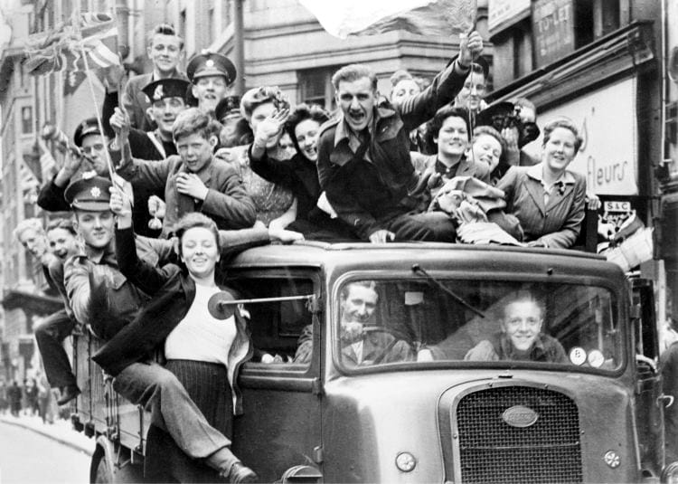
It was on this date that great celebrations took place across Europe and North America: in London over a million people celebrated Victory in Europe (VE) Day. Crowds massed in Trafalgar Square and up the Mall to Buckingham Palace, where King George VI and Queen Elizabeth, accompanied by the Prime Minister Winston Churchill, appeared on the balcony of the Palace to cheering crowds.
Amongst those crowds Princess Elizabeth (the future Queen Elizabeth II) and her sister, Princess Margaret blended anonymously, apparently enjoying the celebrations for themselves first hand.
https://www.english-heritage.org.uk/visit/inspire-me/ve-day/ This site has some ideas for celebrating the day.

