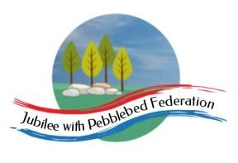
Learning
from Home

Year: 4  Wk beg:  1.3.21 | Lesson One | Lesson Two | Lesson Three | Lesson Four
Monday  The theme for this week’s learning behaviour is  Our learning animal this week is a squirrel 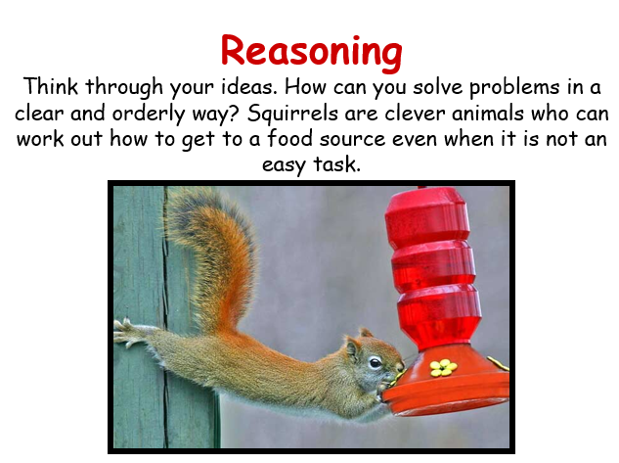 | English  The King of the Birds  LO: To create sentences using expanded noun phrases  Today’s lesson is a focus on making our sentences more exciting by adding description. One way we can do this is to use adjectives to describe a noun.  Go to Google Classroom for the attached sheets and task | Maths  Fractions  LO: To identify equivalent fractions  Go to Google classroom for Powerpoint and practice sheets.  Day 1 | Art  LO: To draw or paint a spring picture  This lesson is for you to enjoy creating a picture. Spring is most definitely springing right now! I have noticed daffodils and signs of new growth in nature! It’s very exciting to see a new season. Go outside for a walk and take a photo of some flowers growing. Draw or paint your flowers or something else which you have noticed on your walk. | Mental health  LO: Stay connected to family and friends  Write a letter or send an email to someone in our family who you haven’t seen in a few weeks. Tell them what you have been doing and ask them how they are! Include a picture of yourself!
Tuesday | English  SPAG  LO: To revise our knowledge of word class  Follow this link for the online lesson.  https://classroom.thenational.academy/lessons/to-revise-our-knowledge-of-word-class-c9k6ct?activity=video&step=1  Go to Google Classroom where there are some word class posters for revision and a game to play.  If you are using the Home Learning pack use the posters to help you revise word class and have a go at the game. | Maths  LO: To solve maths problems using different operations  Go to Google Classroom to find the instructions and clues for a Maths Mystery that you can have a go at solving.  If you have the Home Learning pack you will find the instructions and clues for the Math Mystery there. | RE  LO: To write a diary entry as Mary, mother of Jesus. To think about whether or not Mary would call the day Jesus died Good Friday  Write a simple diary piece for Mary for the entry into Jerusalem, Good Friday and Easter Sunday include a picture of the appropriate cross. In her diary Mary needs to explain why she has included that cross, what has happened on that day, how she feels, and what she thinks the day might mean. When finished children answer the question:  Do you think Mary would call the day Jesus died Good Friday? Why? Why not? | PE  Home work out  https://www.youtube.com/watch?v=h3Xrtm0IVnY
Wednesday | English  The King of the Birds  Fiction  LO: To use adverbial information in sentences  Today we are focussing on adding adverbial information to sentences. This gives the reader more information about how, when and where.  Go to Google classroom | Maths  Fractions  LO: To write fractions in their simplest form  Google classroom Power point Day 2 | Topic Art & Design Traders and Raiders  LO: To create a model Anglo- Saxon house  Look at the links below and watch the clip of the reconstructed Anglo-Saxon site at West Stow in Suffolk.  Go to Google classroom and look at the example models I have put on there. There are some other attachments which show Anglo Saxon buildings and an information sheet about building materials  Task  Create a small model Anglo Saxon house. You could use twigs that you have found in your own garden or out on a walk. You could cut up an old cereal box or use any piece of cardboard. You will need scissors, glue and tape. If you have paint, you could use this too! I look forward to seeing what you have created!  https://www.youtube.com/watch?v=n09vrVfI168  https://kidadl.com/articles/saxon-homes-fact-file-for-kids  https://www.weststow.org/Anglo-Saxon-Village/introductory-video.cfm
Thursday | English  The King of the Birds  Fiction  LO: To plan a story where an animal becomes king or queen in an unusual way.  Today you will make a story plan with a beginning, a middle and an end. Your writing will have some expanded noun phrases like we have practised.  Go to Google classroom for a story plan template | Maths  Fractions  LO: To add and subtract fractions with the same denominator using a number line.  Google classroom  Day 3 | Topic - Traders and Raiders  History  LO: To understand who Alfred the Great was and why he was considered an important figure in history  https://www.bbc.co.uk/bitesize/topics/zxsbcdm/articles/z9tdq6f  Task  Create a fact file about Alfred the Great  You can draw a picture of what he looked like and include facts about his life and why he was considered great! | SPAG  LO: To understand how we use possessive apostrophes for singular and plural nouns.  https://www.bbc.co.uk/bitesize/topics/zvwwxnb/articles/zx9ydxs  Go to Google classroom and find a sheet to practise using the possessive apostrophe  LO: To understand the past perfect tense  https://www.youtube.com/watch?v=7GAjEdOiNaI
Friday | English  The King of the Birds  Fiction  LO: To write my own story based on an animal becoming king or queen in an unusual way.  We will now write our own stories using the grammar techniques we have practised this week. I have brought this unit to a finish due to the children being back in school from next week.  Your story must include some expanded noun phrases and sentences containing adverbial information. We have done lots of work on this in school in the past. Remember that the adverbial part of the sentence does not make sense on its own. Try bringing the adverbial information to the front of your sentence to really engage your reader!  I look forward to reading your stories! | Maths  Fractions maths investigation  LO: To find equivalent fractions and to use knowledge of factors and multiples  Google Classroom  Maths investigation | PE  Home work out  Kick a ball and go for a run in your garden or somewhere local and safe | Game Time  Go to:  https://www.ictgames.com/mobilePage/index.html  and select from Literacy or maths games to play on  Play a board game or a card game with a family member.

