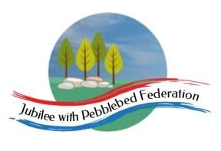
Learning
from Home

Year: 2  Wk beg: 05/01/21 | Lesson One | Lesson Two | Lesson Three | Lesson Four
Tuesday | Maths  https://classroom.thenational.academy/lessons/to-identify-one-half-of-a-shape-60up2c | English  https://classroom.thenational.academy/lessons/to-listen-to-an-information-text-and-answer-questions-6ctp2r | Reading  Please use Bug Club Password supplied to access texts set by Mrs Hooper for your child. | PE  https://www.youtube.com/watc h?v=L_A_HjHZxfI
Wednesday | Maths  https://classroom.thenational.academy/lessons/to-find-half-of-a-quantity-6nhpct | English  https://classroom.thenational.academy/lessons/to-tell-an-information-text-from-memory-6rvker | Reading  Please use Bug Club Password supplied to access texts set by Mrs Hooper for your child. | DTEC  Look at brick patterns around you, how the bricks overlay to make the wall strong. Can you build a strong wall with bricks, or draw a brick pattern?
Thursday | Maths  https://classroom.thenational.academy/lessons/to-find-one-quarter-of-a-shape-c8r66c | English  https://classroom.thenational.academy/lessons/to-use-descriptive-phrases-6xhked | Reading  Please use Bug Club Password supplied to access texts set by Mrs Hooper for your child. | RE  https://classroom.thenational.academy/lessons/how-did-the-religion-of-islam-begin-74vk2r
Friday | Maths  https://classroom.thenational.academy/lessons/to-find-one-quarter-of-a-quantity-6xjkad | English  https://classroom.thenational.academy/lessons/to-use-the-present-tense-ccvkar | Reading  Please use Bug Club Password supplied to access texts set by Mrs Hooper for your child. | Music  https://classroom.thenational.academy/lessons/rhythm-and-pulse-c4tker

