This document is what your children would be doing with Nursery adults for 10 minutes maximum every day. If you child gets fed up do not force them to come back or stay longer, just try again tomorrow!

I think this activity is harder than it seems, it’s important to realise that children need to know the difference between long sounds like a horn blasting and short sounds like a horn beep. Loud and quiet sounds are obvious to us but what about fast and slow sounds? How could you demonstrate that to children? Maybe listening to some fast and slow music? This Action song by the learning station is a fun one to do to learn about sounds getting faster: “A Ram-Sam-Sam”

If you have any problems or queries please do contact school via phone or the Nursery email.

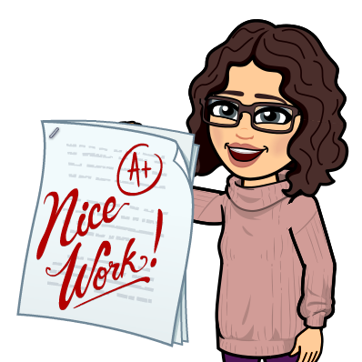Feel free to use the space provided to jot down notes of how well they get on. The “look listen and note” section is really to tell you what the children should be doing and what you need to look out for as evidence of learning.

Most importantly have fun! ~Mrs P

Aspect 3: General sound discrimination – body percussion
Look, listen and note
Look, listen and note how well children:
] use language to make different endings to the story; ] use a wide vocabulary to talk about the sounds they hear; ] use a wide vocabulary to talk about the sounds they hear;
] group sounds according to different criteria (e.g. loud, quiet, slow, fast).
Wk 4:  Activity | Words about sounds: It is important that adults engage with children in their freely chosen activities and introduce vocabulary that helps them to discriminate and contrast sounds, for example:  - slow, fast;  - quiet, loud;  - long, short;  - type of sound (click, stamp, etc.);  - type of movement (rock, march, skip, etc.).  Start with simple opposites that are obviously different (e.g. loud, quiet).  Listen to what the children have to say about the sounds they hear and then build on and expand their contributions and ideas.

