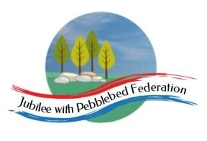
Learning
from Home

Year:  Wk beg: | Lesson One | Lesson Two | Lesson Three | Lesson Four
Monday | Reading  Read library book or allocated bug club books | English  https://classroom.thenational.academy/lessons/to-explore-expanded-noun-phrases-ccwk8d | Maths  https://classroom.thenational.academy/lessons/subtracting-two-3-digit-numbers-without-regrouping-60r3cc | History  https://www.bbc.co.uk/bitesize/articles/zd42xyc
Tuesday | Spelling  https://classroom.thenational.academy/lessons/to-investigate-suffixes-plurals-6nj64c | English  https://classroom.thenational.academy/lessons/to-describe-two-contrasting-settings-and-characters-6ru3er | Maths  https://classroom.thenational.academy/lessons/applying-rounding-for-estimating-adding-65j62r | RE  https://www.bbc.co.uk/bitesize/topics/ztkxpv4/articles/zdjjf4j
Wednesday | Handwriting  https://www.youtube.com/watch?v=2NQ6uS8blwY | English  https://www.bbc.co.uk/bitesize/topics/zkxp2v4/articles/zfgq2sg | Maths  https://classroom.thenational.academy/lessons/applying-rounding-for-estimating-subtracting-64w34c | PE  Go Noodle dances
Thursday | Reading  Read library book or allocated bug club books | English  https://www.bbc.co.uk/bitesize/clips/zhbs34j | Maths  https://classroom.thenational.academy/lessons/adding-two-3-digit-numbers-regrouping-in-one-column-cmt64e | Science  https://www.bbc.co.uk/bitesize/topics/zy66fg8/articles/zcmtk2p
Friday | Reading  Read library book or allocated bug club books | English  https://www.bbc.co.uk/bitesize/articles/zcxnm39 | Maths  https://classroom.thenational.academy/lessons/adding-two-3-digit-numbers-regrouping-in-multiple-columns-74u3ce | Geography  https://www.bbc.co.uk/bitesize/articles/zv67mfr

