Friday 1st May 2020

We have gathered together to worship God the Father, God the Son and God the Holy Spirit and to learn more about Jesus, the light of the world.

In our assembly last week we learnt about the work of Florence Nightingale and we thought about how Jesus wants us each one of us to shine like a candle and to bring light and joy to those around us.
Today we are going to hear about an inspirational gentleman who has proven that each one of us is able to do just that and make a big difference to those around us.

Have a look at the picture below. Do you know who the person is in the picture?

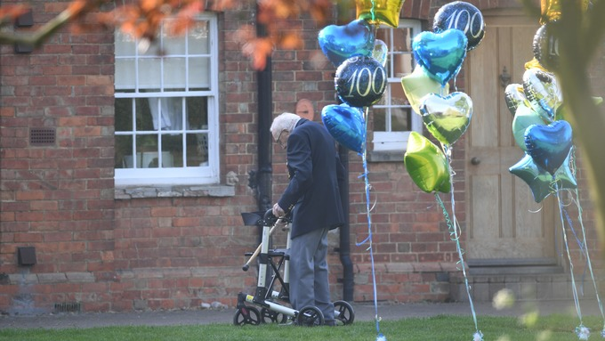

This gentleman is Captain Tom Moore. He was born in West Yorkshire and was a captain in the British Army during World War Two, serving in India and Burma. He was supposed to celebrate his 100th birthday yesterday on the 30th April 2020 by having a birthday party with 100 guests but unfortunately the corona virus pandemic meant that he would not be able to have his party. Instead of feeling sad about this, Captain Tom Moore set himself the challenge of walking 100 laps of his garden to help raise money for the NHS as a way of thanking the NHS staff who helped him with his cancer treatment and to fix his broken hip. He originally aimed to raise £1000 but he quickly passed his target to reach over £28 million pounds for the NHS.

This story shows us that that it is not always the biggest actions that can have the biggest impact and that all of the things that we do affect the world around us. Captain Tom didn’t even leave his garden but he managed to raise a lot of money and raise the spirits of the nation during such difficult circumstances.

Can you think of anything that you can do at the moment to help others?

Mother Teresa, a catholic nun who dedicated her life to helping others once said, “ If you cannot feed a hundred people, feed one.”
What do you think that she meant by this? Do you agree?

However small we think our actions are, we can all contribute to help make a positive difference to the world around us. Why don’t you set yourself a challenge of helping others today.

Let us pray:
God, thank you for showing us you love us by sending us Jesus.
Jesus helps us so we can help others.
We know how important it is to you, that we help each other all we can.
Remind us to do that and give us help when we need it.
In Jesus’ name,
Amen.

Please join together to sing the hymn:

LORD, I LIFT YOUR NAME UP HIGH .
https://www.youtube.com/watch?v=U6I6orjM3NI

Lord, I lift Your name up high;
Lord, I love to sing Your praises.
I’m so glad You’re in my life;
I’m so glad You came to save us .

You came from heaven to earth
To show the way,
From the earth to the cross,
My debt to pay,
From the cross to the grave,
From the grave to the sky,
Lord, I lift Your name up high .

If you would like to read more about Captain Tom Moore’s story then click on the link below
https://bbc.in/2Y0hMsC

If you would like to see a video showing CaptainTom Moore receiving a Pride of Britain award, click on the link below. Notice how thankful he is to everybody.
https://bit.ly/3aAsW9X

And don’t forget to look out for the special postmark that is being used to honour Captain Tom Moore and to mark his 100th birthday.
The Royal Mail postmark reads: “Happy 100th Birthday Captain Thomas Moore NHS fundraising hero 30th April 2020.”

Finally to close our assembly, Finlay has written this prayer for us all.

Let us pray.

Dear God,
Please keep all my friends safe at home. Please keep all my teachers safe. I hope we can go back to school soon. Please give joy to everybody.
Amen

If you would like to write a prayer to share, please email it to the school and we will try to include it in one of our home assemblies.

